

**MASTER OF COMPUTER APPLICATION(MCA)**

(BATCH:2022-2024)

**WEB TECHNOLOGIES LABORATORY**

**(Course Code:PGCA1914)**

**SUBMITTED TO: SUBMITTED BY:**

**NAME: Mrs. Gurmandeep Kaur NAME:Balmiki kumar**

**Assistant Professor ROLL NO. :2235548**

**SEMESTER:2nd**

**DEPARTMENT:MCA**

**INDEX**

|  |  |  |  |  |
| --- | --- | --- | --- | --- |
| **Sr. No.** | **Topic** | **Page No** | **Date of Submission** | **Signature** |
| **1** | **Design a simple HTML page of a book Titled Web Designing.** |  |  |  |
| **2** | **Create a simple HTML page to demonstrate the use of different tags.** |  |  |  |
| **3** | **Display Letter Head of your college on a web page & it must be scrolling Right to Left.** |  |  |  |
| **4** | **Create a link to move within a single page rather than to load another page.** |  |  |  |
| **5** | **Display “Name of University” using different Text formatting Tags.** |  |  |  |
| **6** | **Design Time Table of your department and highlight most important periods.** |  |  |  |
| **7** | **Use Tables to provide layout to your web page.** |  |  |  |
| **8** | **Embed Audio and Video into your web page.** |  |  |  |
| **9** | **Divide a web page vertically and display logo of your college in left pane and logo of university in right pane.** |  |  |  |
| **10** | **Create Bio- Data of an employee.** |  |  |  |
| **11** | **Design front page of a hospital with different styles.** |  |  |  |
| **12** | **Design a web page and display horizontally two different web pages at a time.** |  |  |  |
| **13** | **Write a program to create a login form. On clicking the submit button, the user should get navigated to a profile page.** |  |  |  |
| **14** | **Write a HTML code to create a Registration Form. On submitting the form, the user should be asked to login with the new credentials** |  |  |  |
| **15** | **Write a HTML code to create website in your college or department and create link for Tutorial of specific subject** |  |  |  |
| **16** | **Write a program to perform following operations on two numbers input by the user: Addition 2) Subtraction 3) Multiplication 4) Division.** |  |  |  |
| **17** | **Design a program to solve quadratic equations.** |  |  |  |
| **18** | **Write a program to determine greatest number of three numbers.** |  |  |  |
| **19** | **Write a script to compute, the Average and Grade of students marks.** |  |  |  |
| **20** | **Design a scientific calculator and make event for each button using scripting language.** |  |  |  |
| **21** | **Write a script to check whether a number is even or odd?** |  |  |  |
| **22** | **Write a program to show whether a number is prime or not?** |  |  |  |
| **23** | **Write a program to show multiplication table of any number.** |  |  |  |
| **24** | **Write a program to find the factorial of any number** |  |  |  |
| **25** | **Write a program to show Fibonacci Series between 0 to 74.** |  |  |  |

|  |  |
| --- | --- |
| **01.** | **Design index page of a book Titled Web Designing.** |

<!DOCTYPE html>

<html>

  <head>

    <title>my first page</title>

  </head>

  <style>

    body{

        background-color:#f7f7f7;

    }

    table{

        margin-left:auto;

        margin-right:auto;

        border:1px solid black;

        width:60%;

        border:1px solid black;

    }

    th{

        background-color:#363636;

        color:#fff;

        padding:5px;

    }

    tr{

      background-color: #e5e5e5;

    }

    tr td:hover{

      background-color:#8d8d8d;

      color:#000;

    }

    .bk{

      width:8%;

    }

    .bk8{

      width:11%;

    }

    td{

      padding-left:5px;

    }

    .linktext{

      text-decoration:none;

      }

  </style>

<body>

<div>

  <table title="Index">

    <caption><h1>index</h1></caption>

    <tr title="Syllabus Of Web Technology">

      <th class="bk">Sr No.</th>

      <th>List of Experiments</th>

      <th class="bk8">Page. No.</th>

      <th>Remark</th>

      <th class="bk">Chek</th>

    </tr>

    <tr>

      <td>01.</td>

      <td>Design index page of a book Titled Web Designing.</td>

      <td>1-5</td>

      <td></td>

      <td><a href="#" class="linktext">Clic here</a></td>

    </tr>

    <tr>

      <td>02</td>

      <td>Create a simple HTML page to demonstrate the use of different tags.</td>

      <td>6</td>

      <td></td>

      <td><a href="2nd/tags.html" target="_blank" class="linktext">Clic here</a></td>

    </tr>

    <tr>

      <td>03</td>

      <td>Display Letter Head of your college on a web page & it must be scrolling Right

to  Left.</td>

      <td>7</td>

      <td></td>

      <td><a href="3rd/letter.html" target="_blank" class="linktext">Clic here</a></td>

    </tr>

    <tr>

      <td>04</td>

      <td>Create a link to move within a single page rather than to load another page.</td>

      <td>8</td>

      <td></td>

      <td><a href="loadother.html" target="_blank" class="linktext">Clic here</a></td>

    </tr>

    <tr>

      <td>05</td>

      <td>Display “Name of University” using different Text formatting Tags.</td>

      <td>9</td>

      <td></td>

      <td><a href="Text_formatting.html" target="_blank" class="linktext">Clic here</a></td>

    </tr>

    <tr>

      <td>06</td>

      <td>Design Time Table of your department and highlight most important periods.</td>

      <td>11</td>

      <td></td>

      <td><a href="6th/timetable.html" target="_blank"  class="linktext">Clic here</a></td>

    </tr>

    <tr>

      <td>07</td>

      <td>Use Tables to provide layout to your web page.</td>

      <td>12</td>

      <td></td>

      <td><a href="7th.html" target="_blank" class="linktext">Clic here</a></td>

    </tr>

    <tr>

      <td>08</td>

      <td>Embed Audio and Video into your web page.</td>

      <td>13-15</td>

      <td></td>

      <td><a href="audio/audio.html" target="_blank" class="linktext">Clic here</a></td>

    </tr>

    <tr>

      <td>09</td>

<td>Divide a web page vertically and display logo of your college in left pane and logo of  university in right pane.</td>

      <td>16-18</td>

      <td></td>

      <td><a href="9th/index.html" target="_blank" class="linktext">Clic here</a></td>

    </tr>

    <tr>

      <td>10</td>

      <td>Create Bio- Data of an employee.</td>

      <td>16-18</td>

      <td></td>

      <td><a href="#" class="linktext">Clic here</a></td>

    </tr>

    <tr>

      <td>11</td>

      <td>Design front page of a hospital with different styles.</td>

      <td>19-21</td>

      <td></td>

      <td><a href="#" class="linktext">Clic here</a></td>

    </tr>

    <tr>

      <td>12</td>

      <td>Design a web page and display horizontally two different web pages at a time.</td>

      <td>22-25</td>

      <td></td>

      <td><a href="#" class="linktext">Clic here</a></td>

    </tr>

    <tr>

      <td>13</td>

      <td> Write a program to create a login form. On clicking the submit button, the user

should  get navigated to a profile page.</td>

      <td>26-27</td>

      <td></td>

      <td><a href="#" class="linktext">Clic here</a></td>

    </tr>

    <tr>

      <td>14</td>

      <td>Write a HTML code to create a Registration Form. On submitting the form, the

user  should be asked to login with the new credentials.</td>

      <td>28</td>

      <td></td>

      <td><a href="#" class="linktext">Clic here</a></td>

    </tr>

    <tr>

      <td>15</td>

      <td>Write a HTML code to create website in your college or department and create link  for

Tutorial of specific subject.</td>

      <td>29-33</td>

      <td></td>

      <td><a href="#" class="linktext">Clic here</a></td>

    </tr>

    <tr>

      <td>16</td>

      <td> Write a program to perform following operations on two numbers input by the

user:  Addition 2) Subtraction 3) Multiplication 4) Division.</td>

      <td>34-38</td>

      <td></td>

      <td><a href="#" class="linktext">Clic here</a></td>

    </tr>

    <tr>

      <td>17</td>

      <td>Design a program to solve quadratic equations</td>

      <td>39-40</td>

      <td></td>

      <td><a href="#" class="linktext">Clic here</a></td>

    </tr>

    <tr>

      <td>18</td>

      <td>Write a program to determine greatest number of three numbers.</td>

      <td>41-42</td>

      <td></td>

      <td><a href="#" class="linktext">Clic here</a></td>

    </tr>

    <tr>

      <td>19</td>

      <td>Write a script to compute, the Average and Grade of students marks.</td>

      <td>43-44</td>

      <td></td>

      <td><a href="#" class="linktext">Clic here</a></td>

    </tr>

    <tr>

      <td>20</td>

      <td>Design a scientific calculator and make event for each button using

scripting  language.</td>

      <td>45-48</td>

      <td></td>

      <td><a href="#" class="linktext">Clic here</a></td>

    </tr>

    <tr>

      <td>21</td>

      <td>Write a script to check whether a number is even or odd?</td>

      <td>49-50</td>

      <td></td>

      <td><a href="#" class="linktext">Clic here</a></td>

    </tr>

    <tr>

      <td>22</td>

      <td>Write a program to show whether a number is prime or not?</td>

      <td>51-52</td>

      <td></td>

      <td><a href="#" class="linktext">Clic here</a></td>

    </tr>

    <tr>

      <td>23</td>

      <td>Write a program to show multiplication table of any number.</td>

      <td>53-54</td>

      <td></td>

      <td><a href="#" class="linktext">Clic here</a></td>

    </tr>

    <tr>

      <td>24</td>

      <td>Write a program to find the factorial of any number.</td>

      <td>55-56</td>

      <td></td>

      <td><a href="#" class="linktext">Clic here</a></td>

    </tr>

    <tr>

      <td>25</td>

      <td>Write a program to show Fibonacci Series between 0 to 74.</td>

      <td>57-60</td>

      <td></td>

      <td><a href="#" class="linktext">Clic here</a></td>

    </tr>

  </table>

  <h1></h1>

</div>

</body>

</html>

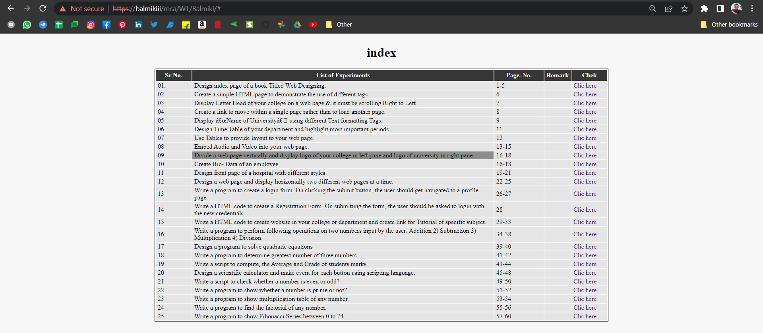

|  |  |
| --- | --- |
| **02** | **Create a simple HTML page to demonstrate the use of different tags.** |

<!DOCTYPE html>

<html>

<head>

  <title>tags</title>

</head>

<style>

  table{

    padding-left: 3%;

  }

  td{

    font-family: open sans;

    font-weight: 700;

    background-color: #e2e2e2;

    border-radius: 25px;

    padding: 17px;

    box-shadow: 5px 5px 5px #666666;

    width: 58%;

  }

  .ml5{

    margin-left: 1%;

  }

    .red{

    color: red;

  }

  .space{

    margin-left: 35px;

  }

  .border{

    border: 1px solid black;

  }

</style>

<body>

  <table>

    <tr>

      <h1>Diffrent tags using</h1>

    </tr>

    <tr>

      <td><span class="ml5"><</span><span class="red">html</span><span>>

</span><spna><</span>/<spna class="red">html</spna><span>></span><span class="space">Start

and end document.</span></td>

    </tr>

    <tr>

      <td><span class="ml5"><</span><span class="red">h1</span><span>>

</span><spna><</span>/<spna class="red">h1</spna><span>></span><span class="space">Header size 1-6 (Larger to small).</span></td>

    </tr>

    <tr>

      <td><span class="ml5"><</span><span class="red">p</span><span>> </span><spna><</span>/<spna

class="red">p</spna><span>></span><span class="space">Paragraph tag.</span></td>

    </tr>

    <tr>

      <td><span class="ml5"><</span><span class="red">b</span><span>> </span><spna><</span>/<spna

class="red">b</spna><span>></span><span class="space">Bold text tag.</span></td>

    </tr>

    <tr>

      <td><span class="ml5"><</span><span class="red">i</span><span>> </span><spna><</span>/<spna

class="red">i</spna><span>></span><span class="space">Italics tag.</span></td>

    </tr>

    <tr>

      <td><span class="ml5"><</span><span class="red">u</span><span>> </span><spna><</span>/<spna

class="red">u</spna><span>></span><span class="space">Under Line.</span></td>

    </tr>

    <tr>

      <td><span class="ml5"><</span><span class="red">li</span><span>>

</span><spna><</span>/<spna class="red">li</spna><span>></span><span class="space">List item tag.</span></td>

    </tr>

    <tr>

      <td><span class="ml5"><</span><span class="red">table</span><span>>

</span><spna><</span>/<spna class="red">table</spna><span>></span><span class="space">Basic table tag.</span></td>

    </tr>

    <tr>

      <td><span class="ml5"><</span><span class="red">abbr</span><span>>

</span><spna><</span>/<spna class="red">abbr</spna><span>></span><span class="space">Defines an abbreviation or an acronym.</span></td>

    </tr>

    <tr>

      <td><span class="ml5"><</span><span class="red">a</span><span>> </span><spna><</span>/<spna

class="red">a</spna><span>></span><span class="space">Defines a hyperlink.</span></td>

    </tr>

    <tr>

      <td><span class="ml5"><</span><span class="red">audio</span><span>>

</span><spna><</span>/<spna class="red">audio</spna><span>></span><span class="space">Defines embedded sound content.</span></td>

    </tr>

    <tr>

      <td><span class="ml5"><</span><span class="red">bdo</span><span>>

</span><spna><</span>/<spna class="red">bdo</spna><span>></span><span class="space">Overrides the current text directionbuttonspan></td>

    </tr>

    <tr>

      <td><span class="ml5"><</span><span class="red">button</span><span>>

</span><spna><</span>/<spna class="red">button</spna><span>></span><span class="space">Defines a clickable button.</span></td>

    </tr>

    <tr>

      <td><span class="ml5"><</span><span class="red">mark</span><span>>

</span><spna><</span>/<spna class="red">mark</spna><span>></span><span class="space">Defines marked/highlighted text.</span></td>

    </tr>

    <tr>

      <td><span class="ml5"><</span><span class="red">ol</span><span>>

</span><spna><</span>/<spna class="red">ol</spna><span>></span><span class="space">Defines an ordered list.</span></td>

    </tr>

    <tr>

      <td><span class="ml5"><</span><span class="red">option</span><span>>

</span><spna><</span>/<spna class="red">option</spna><span>></span><span class="space">Defines an option in a drop-down list</span></td>

    </tr>

    <tr>

      <td><span class="ml5"><</span><span class="red">script</span><span>>

</span><spna><</span>/<spna class="red">script</spna><span>></span><span class="space">Defines a client-side script.</span></td>

    </tr>

    <tr>

      <td><span class="ml5"><</span><span class="red">sub</span><span>>

</span><spna><</span>/<spna class="red">sub</spna><span>></span><span class="space">Defines subscripted text.</span></td>

    </tr>

    <tr>

      <td><span class="ml5"><</span><span class="red">sup</span><span>>

</span><spna><</span>/<spna class="red">sup</spna><span>></span><span class="space">Defines superscripted text.</span></td>

    </tr>

    <tr>

      <td><span class="ml5"><</span><span class="red">td</span><span>>

</span><spna><</span>/<spna class="red">td</spna><span>></span><span class="space">Defines a cell in a table.</span></td>

    </tr>

  </table>

</body>

</html>

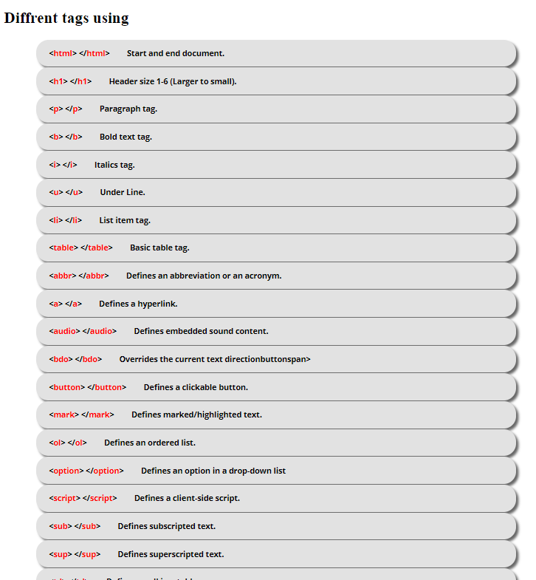

|  |  |
| --- | --- |
| **03** | **Display Letter Head of your college on a web page & it must be scrolling Right to Left.** |

<html>

    <head>

        <title>

            College Department Details

        </title>

        <link href="css/bootstrap.min.css" rel="stylesheet">

        <script src="js/bootstrap.bundle.min.js"></script>

        <link href="//maxcdn.bootstrapcdn.com/font-awesome/4.7.0/css/font-awesome.min.css" rel="stylesheet">

        <style>

            body{

                background-color: #bababa;

                padding:0px 23%;

            }

        h1,h4{

            margin-left:117px;

        }

            .title_head{

                background-color: #9b9b9b;

            }

            .logo{

                float:left;

            }

            .list-area{

                float:right;

                margin-right:20%;

            }

            .body_main{

                margin-top: 163px;

                margin-left: 38%;

            }

            ol{

                margin-top: 16px;

            }li

            {

                list-style:none;

            }

            li i{

                color: #000;

                padding-right: 10px;

            }

            .list-area1{

                border-top: 1px solid black;

                margin-left: auto;

                margin-right: auto;

            }

            .textarea{

                border: 1px solid #000;

                padding:    0px 10px;

            }

            .cee{

                padding: 0px 50px;

            }

        </style>

    </head>

    <body>

        <div class="textarea">

            <span class="logo">

                <img src='logo.jpg' width="100" height="100">

            </span>

            <div class="title_head">

                <h1>CHANDIGARH GROUP OF COLLEGES</h1>

                <h4 class="pb-3">Buldling careers,Transforing Lives</h4>

            </div>

            <div class="list-area1">

                <div class="list-area">

                    <ol>

                        <li><i class="fa fa-map-marker"></i>Jhanjeri mohali</li>

                        <li><i class="fa fa-phone"></i>1800 274 0444</li>

                        <li><i class="fa fa-globe"></i>www.cgc.ac.in</li>

                    </ol>

                    <p>Date: 28/02/2023</p>

                </div>

                <div>

                <h4 class="body_main">Acadmic fee Notice </h4>

                <div class="cee">

                    <p class="text-justify">In Continuation of the previous notice dated: 14/12/2022, This is again informed to all the first year students of 2022 batch and including 2022 Leet batch, that they are required to pay the pending dues of current semester (if any) and academic fee of upcoming even semester before the last date of filling of examination form i.e. 04/01/2023 as announced by IKGPTU. The examination form of current semester will not be accepted until the students clear the academic dues for upcoming even semester.

                    </p>

                    <br>

                   <p class="cee">All the student can pay fee online at https://www.cgc.ac.in/pay-fee-online</p>

                        <p>Dr.Neeraj Sharma</p></h3>

                        <p>Executive Director</p>

                    <p>Cc:</p>

                    <ol>

              <li>Hon'ble President Sir-for his kind information through OSD.</li>

              <li>Hon'ble Managing Director Sir-for his kind information through Sr. Ececutive.</li>

              <li>Director Academic</li>

              <li>Director(Engg.,Mgmt,and Low)(with a reqest to share among each students)</li>

              <li>CFO</li>

              <li>Director Admin(with a reqest to display on Hostel's Notice Board)</li>

              <li>DSW Department</li>

              <li>International Deplartment</li>

            </ol>

                </div>

                </div>

            </div>

        </div>

    </body>

</html>

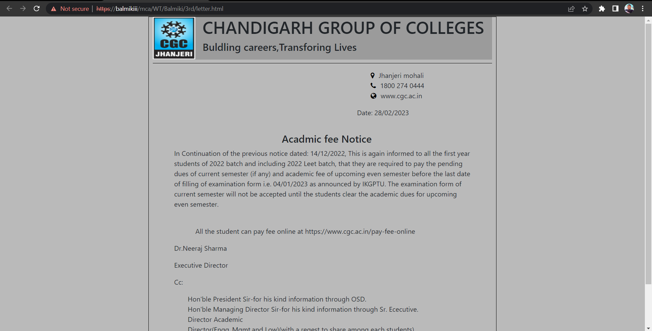

|  |  |
| --- | --- |
| **04** | **Create a link to move within a single page rather than to load another page.** |

<!DOCTYPE html>

<html>

<head>

    <title>load other Page</title>

    <style>

        .button{

            text-decoration: none;

            background-color: #c3ffc3;

            color: black;

            line-height: 14px;

            padding: 13px;

            border: 2px solid black;

            border-radius: 13px;

            float: right;

        }

    </style>

</head>

<body>

    <h1>Define HTML</h1>

    <p>HTML stands for Hyper Text Markup Language. HTML is the standard markup language for creating Web pages. HTML describes the structure of a Web page. HTML consists of a series of elements. HTML elements tell the browser how to display the content.</p>

    <h1>Advantage</h1>

    <a href="https://www.scaler.com/topics/advantages-of-html/" class="button">Click for other page</a>

    <a href="https://www.cgc.ac.in/" class="button">Visite CGC</a>

    <div class="markdown-body"><section class="main"><p><strong>1. HTML is simple to understand and implement<strong></p><ul>

        <li>HTML is a simple language to learn and understand. HTML is the first and most important language that anyone learning web development will encounter. There are no complicated tags, and there is no case sensitivity with HTML.</li>

        <li>It consists of only a few tags that have a specific purpose. One can easily grasp others’ code and make adjustments if necessary, so there isn't much more to learn from it. Moreover, unlike other programming languages, it does not throw an error or cause a problem if the developer forgets to close the tags or makes a mistake in the code.</li>

        </ul><p><strong>2. HTML is completely free</strong></p><ul>

        <li>One of the biggest advantages of using HTML is that it is free, and no special software is required. HTML does not require any plugins, so one should not have to deal with them when working with any software.</li>

        <li>Even with many open-source content management systems, all necessary plugins are not always free. As a result, it is incredibly cost-effective from a per-business standpoint because there is no fee for obtaining the license if the entire website is constructed in HTML.</li>

        </ul><p><strong>3. Every browser supports HTML</strong></p><ul>

        <li>HTML is supported by nearly all browsers worldwide such as Google, Safari, Opera, etc. So there is no need to be concerned about a website built in HTML for browser support because the website will appear in all browsers if the program&nbsp;remembers to optimize the website for the different browsers.</li>

        <li>It is neither difficult nor complex to optimize an HTML-based website for browser compatibility. It gives web developers an easy way to optimize their websites for browsers.</li>

        </ul><p><strong>4. HTML is the most search engine friendly</strong></p><ul>

        <li>In comparison to other web programming languages on the market, HTML is one of the most user-friendly search engines (Search Engine friendly means delivering users quality websites with relevant information when searching for a particular one).</li>

        <li>HTML is far easier to use than other computer languages for creating <span class="highlight--red">SEO-compliant websites</span>. HTML websites are more accessible for web crawlers to read and access, reducing crawling time and page load time and so enhancing website performance.</li>

        <li>HTML generates the fewest SEO difficulties and offers the most flexibility when attempting to construct an SEO-compliant website. As long as you verify that your HTML code is clean and validated.</li>

</body>

</html>

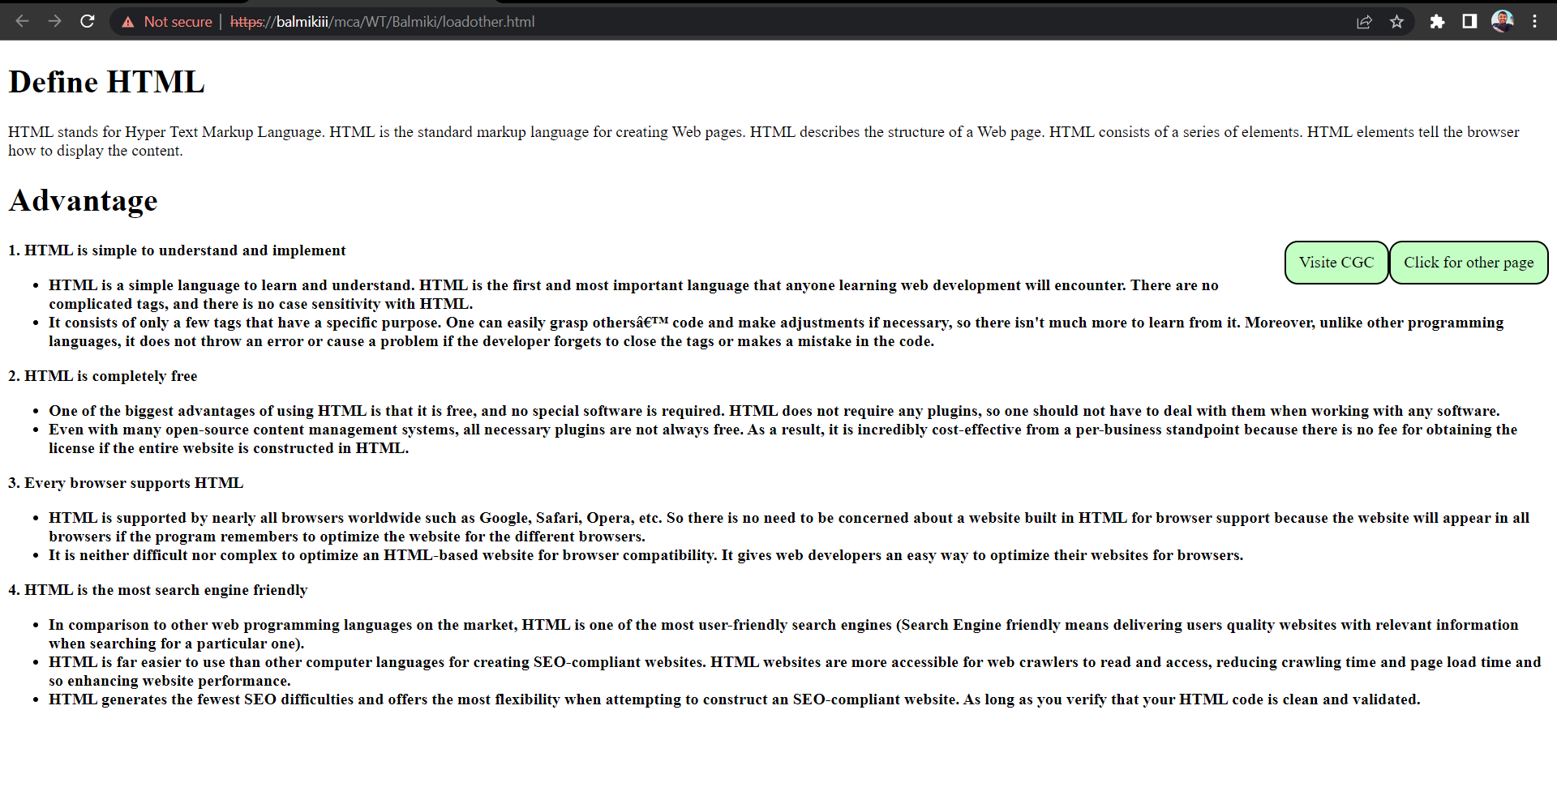

|  |  |
| --- | --- |
| **05** | **Display “Name of University” using different Text formatting Tags.** |

<!DOCTYPE html>

<html>

<head>

<style>

h1 {

  text-shadow: 4px 6px 4px green;}

.pp{

  text-shadow: 6px 7px 2px #adadad;}

h2{

  text-shadow: 2px 2px 8px #000000; }

</style>

</head>

<body>

<p>Diffrent formates</p>

<h1>Punjab Technical university</h1>

<p class="pp">Punjab Technical university</p>

<h2>Punjab Technical university</h2>

<h3>Punjab <mark>Technical</mark> university</h3>

<h3>Punjab <u>Technical</u> university</h3>

<p>Punjab <b>Technical</b> <i>university</i></p>

</body>

</html>

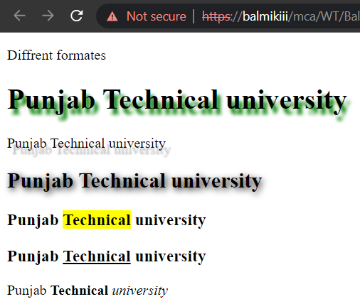

|  |  |
| --- | --- |
| **06** | **Design Time Table of your department and highlight most important periods.** |

<!DOCTYPE html>

<html>

    <head>

        <title>Time table</title>

        <style>

            table{

                width: 95%;

            }

            table,th,td{

                border:1px solid black;

                text-align:center;

                border-collapse: collapse;

            }

            .yellow-cell{

                background-color: #fab800;

            }

            .green-cell{

                background-color: green;

            }

            .blue-cell{

                background-color: #dedaff;

            }

            .none{

                background-color: #fff;

            }

            .wite{

                color:white;

            }

        </style>

    </head>

    <body>

        <table>

            <tr class="blue-cell">

                <th class="none"></th>

                <th>09:30am 10:20am</th>

                <th>10:20am 11:10am</th>

                <th>11:10am 12:00am</th>

                <th>12:00pm 12:50pm</th>

                <th>12:50pm 01:35pm</th>

                <th>01:35pm 02:20pm</th>

                <th>02:20pm 03:05pm</th>

                <th>03:05pm 03:50pm</th>

                <th>03:50pm 04:35pm</th>

            </tr>

            <tr>

                <th rowspan=6>Monday</th>

                <td>Vibhooti(LR)</td>

                <td>Information Security</td>

                <td>Niraj(SS)</td>

                <td rowspan=35>lunch</td>

                <td>Advance java Lab</td>

                <td>Web technology</td>

                <td colspan=2>Advance Java lab G1</td>

                <td>linux</td>

            </tr>

            <tr>

                <td></td>

                <td></td>

                <td></td>

                <td>429</td>

                <td></td>

                <td colspan=2>24</td>

                <td></td>

            </tr>

            <tr>

                <td class="yellow-cell">CCPD</td>

                <td>Mr Gurmandeep</td>

                <td class="yellow-cell">CCPD</td>

                <td class="green-cell">Ms pragti</td>

                <td class="green-cell">Ms gurmandeep kaur</td>

                <td colspan=2 class="green-cell">Ms pragti</td>

                <td class="green-cell">Mr Navin</td>

            </tr>

            <tr>

                <td></td>

                <td></td>

                <td></td>

                <td></td>

                <td></td>

                <td colspan=2>Web technology G2</td>

                <td></td>

            </tr>

            <tr>

                <td></td>

                <td></td>

                <td></td>

                <td></td>

                <td></td>

                <td colspan=2>220</td>

                <td></td>

            </tr>

            <tr class="green-cell">

                <td></td>

                <td></td>

                <td></td>

                <td></td>

                <td></td>

                <td colspan=2>Mr Sourav</td>

                <td></td>

            </tr>

            <tr>

                <th rowspan=7>Tuesday</th>

                <td>DDA</td>

                <td>Advance java</td>

                <td class="yellow-cell">Anuja (VA)</td>

                <td>Advance java Lab</td>

                <td class="yellow-cell">Shanjay DS</td>

                <td>Information Security</td>

                <td colspan=2>Web technology lab G2</td>

            </tr>

            <tr>

                <td></td>

                <td></td>

                <td></td>

                <td>422</td>

                <td></td>

                <td></td>

                <td colspan=2>220</td>

            </tr>

            <tr>

                <td class="green-cell">Ms smriti</td>

                <td class="green-cell">Dr. Anand sukla</td>

                <td></td>

                <td class="green-cell">Ms pragti</td>

                <td colspan=2></td>

                <td colspan=2 class="green-cell">Mr Sourav</td>

            </tr>

            <tr>

                <td></td>

                <td><td>

                <td></td>

                <td></td>

                <td></td>

                <td colspan=2>Linux Lab G1</td>

            </tr>

            <tr>

                <td></td>

                <td><td>

                <td></td>

                <td></td>

                <td></td>

                <td colspan="2">24</td>

            </tr>

            <tr class="green-cell">

                <td></td>

                <td class="green-cell"></td>

                <td class="yellow-cell">CCPD</td>

                <td class="green-cell"></td>

                <td rowspan="2" class="yellow-cell">CCPD</td>

                <td>Ms Gaganpreet<td>

                <td colspan="2">Mr Navin</td>

            </tr>

            <tr class="green-cell">

                <td></td>

                <td class="green-cell"></td>

                <td class="yellow-cell"></td>

                <td class="green-cell"></td>

                <td class="none wite">CCPD<td>

                <td colspan="2"></td>

            </tr>

            <tr>

                <th class="none" rowspan=6>Wednesday</th>

                <td>linux</td>

                <td>Web technology</td>

                <td>Naveen(Quant)</td>

                <td>DDA</td>

                <td>Advance java</td>

                <td colspan="2">Web technology lab G1</td>

                <td>Advance Java G1</td>

            </tr>

            <tr>

                <td></td>

                <td></td>

                <td></td>

                <td></td>

                <td></td>

                <td colspan="2">220</td>

                <td>318</td>

            </tr>

            <tr class="green-cell">

                <td>Mr Naveen</td>

                <td>Ms Gurmandeep</td>

                <td class="yellow-cell">CCPD</td>

                <td>Ms Samriti</td>

                <td>Dr. Anand sukla</td>

                <td colspan="2">Ms Gurmandeep</td>

                <td>Ms pragti</td>

            </tr>

            <tr>

                <td></td>

                <td></td>

                <td></td>

                <td></td>

                <td></td>

                <td colspan="2">Linux <label for=""></label></td>

                <td>Library</td>

            </tr>

            <tr>

                <td></td>

                <td></td>

                <td></td>

                <td></td>

                <td></td>

                <td colspan="2">318</td>

                <td></td>

            </tr>

            <tr>

                <td></td>

                <td></td>

                <td></td>

                <td></td>

                <td></td>

                <td class="green-cell" colspan="2">Mr Naveen</td>

                <td class="green-cell"></td>

            </tr>

            <tr>

                <th class="none" rowspan=6>Thruday</th>

                <td>Web Technology</td>

                <td>linux</td>

                <td>DDA</td>

                <td>Advance Java</td>

                <td>Information Security</td>

                <td colspan="2">Web Technology Lab</td>

                <td>Advance Java Lab G1</td>

            </tr>

            <tr>

                <td></td>

                <td></td>

                <td></td>

                <td></td>

                <td></td>

                <td colspan="2">220</td>

                <td>318</td>

            </tr>

            <tr class="green-cell">

                <td>Ms Gurmandeep kaur</td>

                <td>Mr. Naveen</td>

                <td>Ms Samriti</td>

                <td>Dr. Aanand sukla</td>

                <td>Ms Gaganpreet</td>

                <td colspan="2">Ms Gurmandeep G1</td>

                <td>Ms Pragati</td>

            </tr>

            <tr>

                <td></td>

                <td></td>

                <td></td>

                <td></td>

                <td></td>

                <td colspan="2">Linux Lab G2</td>

                <td>Library</td>

            </tr>

            <tr>

                <td></td>

                <td></td>

                <td></td>

                <td></td>

                <td></td>

                <td colspan="2">318</td>

                <td></td>

            </tr>

            <tr>

                <td></td>

                <td></td>

                <td></td>

                <td></td>

                <td></td>

                <td colspan="2" class="green-cell">Mr Naveen</td>

                <td class="green-cell"></td>

            </tr>

            <tr>

                <th class="none" rowspan=6>Friday</th>

                <td>linux</td>

                <td>Web Technology</td>

                <td>DDA</td>

                <td>Advance Java</td>

                <td>Abhishek Python</td>

                <td>Information Security</td>

                <td colspan="2">Linux Lab G1</td>

            </tr>

            <tr>

                <td></td>

                <td></td>

                <td></td>

                <td></td>

                <td></td>

                <td></td>

                <td colspan="2">318</td>

            </tr>

            <tr class="green-cell">

                <td>Mr Naveen</td>

                <td>Ms Gurmandeep kaur</td>

                <td>Ms Samriti</td>

                <td>Dr. Anand sukla</td>

                <td class="yellow-cell">CCPD</td>

                <td>Ms Gaganpreet</td>

                <td colspan="2">Mr Naveen</td>

            </tr>

            <tr>

                <td></td>

                <td></td>

                <td></td>

                <td colspan="2"></td>

                <td></td>

                <td colspan="2">Advance Java G2</td>

            </tr>

            <tr>

                <td></td>

                <td></td>

                <td></td>

                <td colspan="2"></td>

                <td></td>

                <td colspan="2">220</td>

            </tr>

            <tr class="green-cell">

                <td></td>

                <td></td>

                <td></td>

                <td colspan="2"></td>

                <td class="none"></td>

                <td colspan="2">Ms Pragati</td>

            </tr>

        </table>

    </body>

</html>

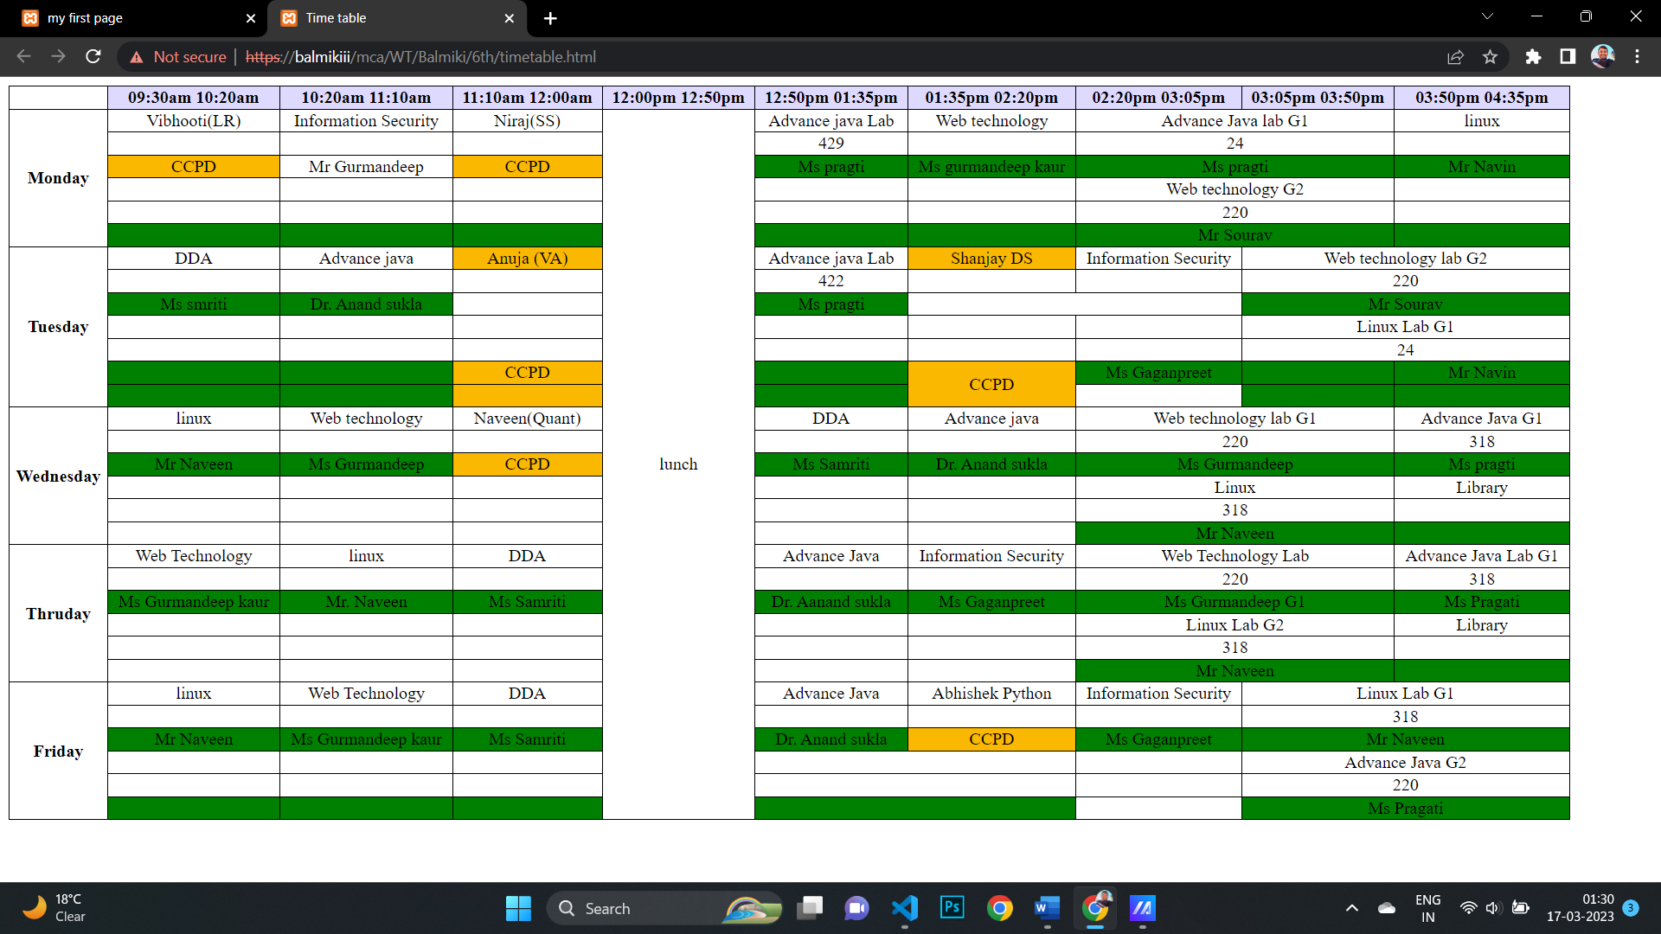

|  |  |
| --- | --- |
| **07** | **Use Tables to provide layout to your web page.** |

<!DOCTYPE html>

<html>

<head>

    <title>Layout</title>

</head>

<style>

    table{

        width:100%;

    }

    table .con{

        line-height: 450px;

    }

    table .conten{

        text-align: center;

        background-color: tomato;

    }

    .gr{

    }

    .head{

        line-height: 50px;

        margin: 0px !important;

        background-color: green;

    }

    .foot{

        line-height: 100px;

        color: white;

    }

    .bl{

        background-color: black;

    }

</style>

<body>

    <table>

        <tr class="gr">

            <h1 colspan="2" class="head">CGC</h1>

        </tr>

        <tr class="con">

            <th style="width:50%" class="conten">CGC</th>

            <th style="width:50%" class="conten">PTU</th>

        </tr>

        <tr class="bl">

            <th colspan="2" class="foot">Balmiki ( 2235548 )</th>

        </tr>

    </table>

</body>

</html>

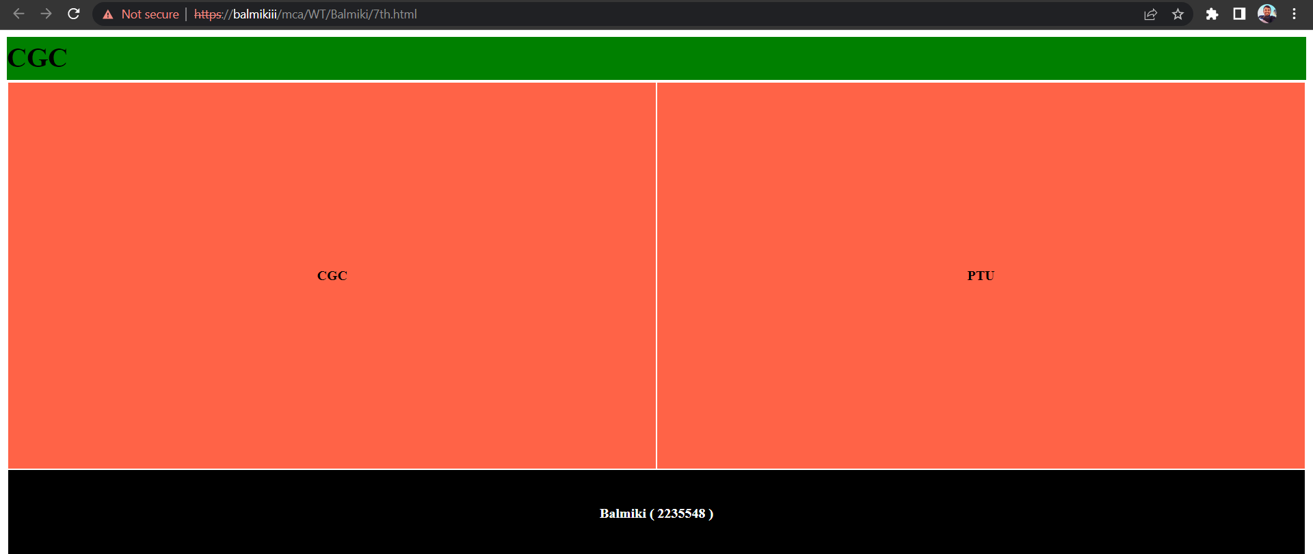

|  |  |
| --- | --- |
| **08** | **Embed Audio and Video into your web page** |

<!DOCTYPE html>

<html>

<head>

    <title>My audio video</title>

</head>

<style>

    table{

        width:100%;

    }

    table .conten{

        background-color: rgb(120, 158, 198);

    }

    .head{

        line-height: 50px;

        margin: 0px !important;

        background-color: green;

        text-align: center;

    }

    .foot{

        line-height: 100px;

        color: white;

    }

    .bl{

        background-color: black;

    }

</style>

<body>

    <table>

        <tr class="gr">

            <h1 colspan="2" class="head">CGC</h1>

        </tr>

        <tr class="con">

            <th style="width:50%" class="conten">

                <div class="left">

                    <audio src="balmiki2.mp3" controls></audio><br>

                    <audio src="balmiki.mp3" controls></audio>

                </div>

                <h1>Play Audio</h1>

            </th>

            <th style="width:50%" class="conten">

                <div>

                    <iframe width="560" height="315" src="https://www.youtube.com/embed/52z_fdKPuOo" title="YouTube video player" frameborder="0" allow="accelerometer; autoplay; clipboard-write; encrypted-media; gyroscope; picture-in-picture; web-share" allowfullscreen></iframe>

                </div>

                <h1>Play Balmiki Video</h1>

            </th>

        </tr>

        <tr class="bl">

            <th colspan="2" class="foot">Balmiki ( 2235548 )</th>

        </tr>

    </table>

</body>

</html>

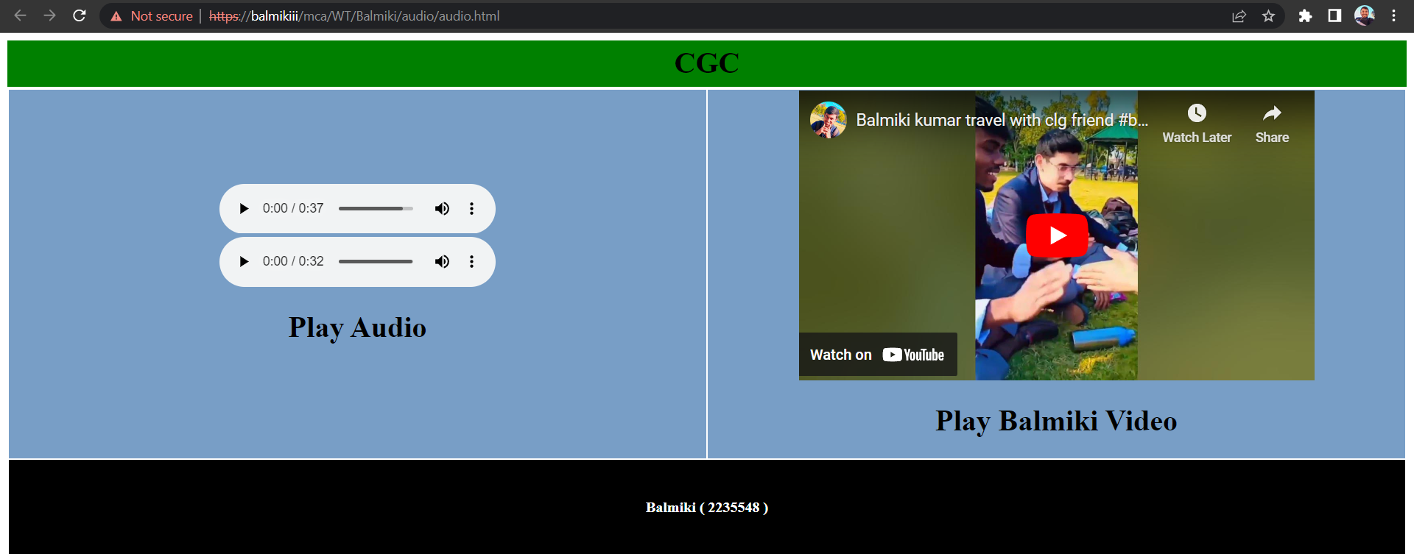

|  |  |
| --- | --- |
|  | **09 Divide a web page vertically and display logo of your college in left pane and logo of university in right pane.** |

<!DOCTYPE html>

<html>

<head>

    <title>Display logo</title>

    <style>

        .left{

            float: left;

            border: 1px solid black;

        }

        .right{

            float: right;

            border: 1px solid black;

        }

        div{

            width: 49%;

            line-height: 50px;

        }

    </style>

</head>

<body>

    <div class="left">

        <img src="cgc.jpg" alt="logo" width="200px"; height="auto">

        <h1>Chandigarh Group Of Collage</h1>

    </div>

    <div class="right">

        <img src="ptu.gif" alt="logo" width="200px"; height="auto">

        <h1>Punjab Technical University</h1>

    </div>

</body>

</html>

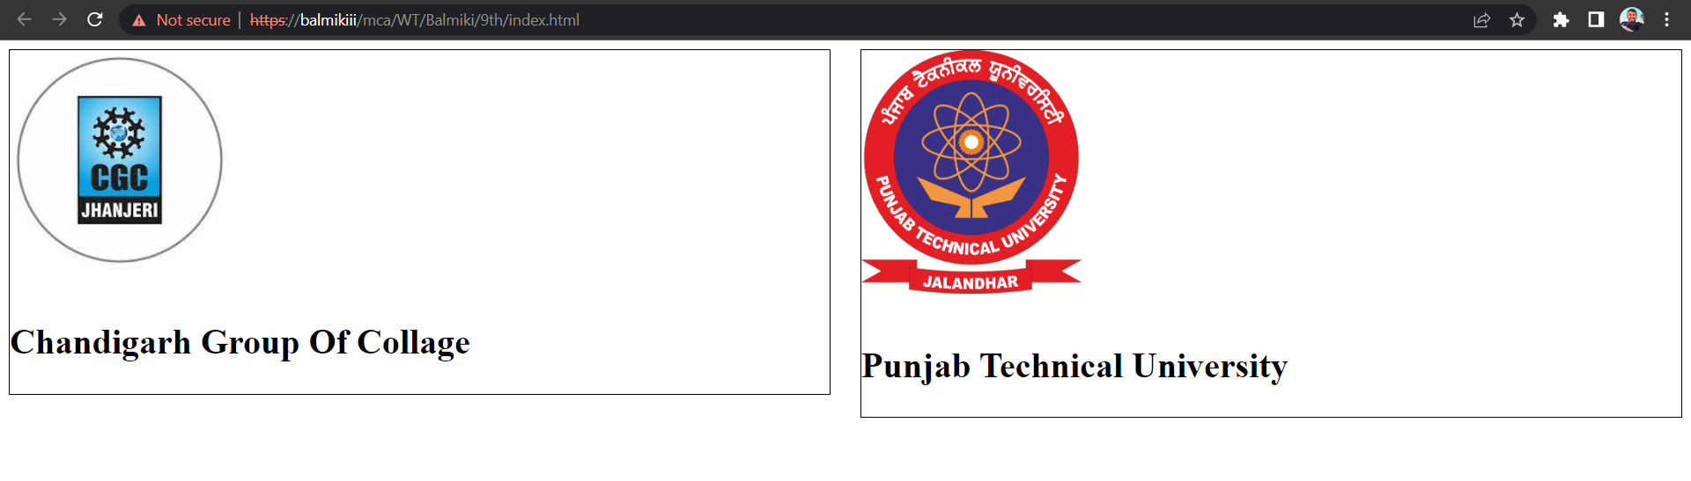

**10th Create Bio- Data of an employee.**

<!DOCTYPE html>

<html>

<head>

    <title>Bio-Data</title>

</head>

<style>

    .resume{

        border: 1px solid black;

        width: 70%;

        margin-left: auto;

        margin-right: auto;

        font-family: open sans;

        padding-bottom: 25px;

    }

    .resume h3{

        text-align: center;

    }

    .resume .head{

        display: flex;

        border-top: 2px solid black;

        border-bottom: 2px solid black;

        margin: 0px 5px;

    }

    .resume .body{

        margin: 0px 5px;

    }

    .link{

        color: black;

        text-decoration: none;

    }

    .listnone{

        list-style: none;

    }

    .resume .head .img{

        margin-left: 375px;

    }

    table{

        width: 96%;

    }

    table td{

        color: #3e3e3e;

    }

    table,th,td{

        border-collapse: collapse;

        border: 1px solid black;

    }

    .f-l{

        float: left;

    }

    .f-r{

        float: right;

        margin-right: 250px;

    }

    .body .listnone{

        padding-top: 10px;

    }

    .body td{

        padding-left: 10px;

    }

    .body .mr{

        padding-left: 10px;

    }

    .font_weight li{

        font-weight: 600;

    }

</style>

<body>

    <div class="resume">

        <h3>Bio-Data</h3>

        <div class="head">

            <div class="information">

                <ol>

                    <li class="listnone"><b>Balmiki kumar</b></li>

                    <li class="listnone">H.1556, st.01, Baba deep singh nagar, Sherpur<br>kalan, Focal point, Ludhiana, Punjab(141010)</li>

                    <li class="listnone"><a href="mailto:balmikikumar0786@gmail.com" class="link">balmikikumar0786@gmail.com</a></li>

                    <li class="listnone"><a href="tel:917087063168" class="link">+91-70870-63168</a></li>

                </ol>

            </div>

            <div class="img">

                <img src="Balmiki.jpg" alt="Balmiki" width="100px"; height="auto">

            </div>

        </div>

        <div class="body">

            <ol>

                <li class="listnone"><b>Objective : </b>Secure a responsible career opportunity & fully utilize my training and skills, while making a significant contribution to the success of the company. </li>

                <li class="listnone"><b>Education :</b></li>

                <table>

                    <tr>

                        <th>Qualification</th>

                        <th>Board</th>

                        <th>School</th>

                        <th>Passing years</th>

                        <th>Percentage</th>

                        <th>Grades</th>

                    </tr>

                    <tr>

                        <td>10<sup>th</sup></td>

                        <td>PSEB</td>

                        <td>Bharat sewak adarsh vidyalaya</td>

                        <td>2017</td>

                        <td>60.76 %</td>

                        <td>B</td>

                    </tr>

                    <tr>

                        <td>12<sup>th</sup></td>

                        <td>PSEB</td>

                        <td>SDP.Sen.Sec.Schoo</td>

                        <td>2018</td>

                        <td>52.42 %</td>

                        <td>C</td>

                    </tr>

                    <tr>

                        <td>BCA</td>

                        <td>PTU</td>

                        <td>Ludhiana college of engineering

                            & technology</td>

                        <td>2022</td>

                        <td>74.4 %</td>

                        <td>7.44 SGPA</td>

                    </tr>

                    <tr>

                        <td>MCA</td>

                        <td>PTU</td>

                        <td>Chandigadh Group of Collage

                            Jhanjheri, mohali</td>

                        <td>Purssing</td>

                        <td>---</td>

                        <td>---</td>

                    </tr>

                </table>

                <li class="listnone font_weight"><b>Personnal detail :</b>

                    <ul type="disc">

                        <li>D.O.B : 13 Oct 2000</li>

                        <li>Gender : Male</li>

                        <li>Matrial status : Unmarried</li>

                        <li>Father Name : Mr. Ayodhya pandit</li>

                        <li>Religeon : Hindu </li>

                        <li>Nationality : Indian </li>

                        <li>Blood Group : A+</li>

                        <li>Height : 165cm </li>

                        <li>Weight : 56kg</li>

                    </ul>

                </li>

                <li class="listnone mr"><b>Language Known :</b>

                    <ul type="none">

                        <li>Hindi</li>

                        <li>Punjabi</li>

                        <li>English</li>

                    </ul>

                </li>

                <li class="listnone mr"><b>Hobbies :</b>

                    <ul type="none">

                        <li>internet surfing</li>

                        <li>codding</li>

                        <li>Gain new skills</li>

                    </ul>

                </li>

                <li class="listnone"><b>Experience:</b>

                    <ul type="none">

                        <li>I have 6th Month experience of Social Media Marketing, Adobe Photoshop & Web designing & Development in Eb Soft Tech. </li>

                        <li> I here by declare that all tha informarion furnished true to the best of my knowledge <span>&</span> belief.</li>

                    </ul>

                </li>

                <li class="listnone f-l"><b>Place : </b>CGC Jhanjheri, Mohali.</li>

                <li class="listnone f-r"><b>Date :</b></li>

            </ol>

        </div>

    </div>

</body>

</html>

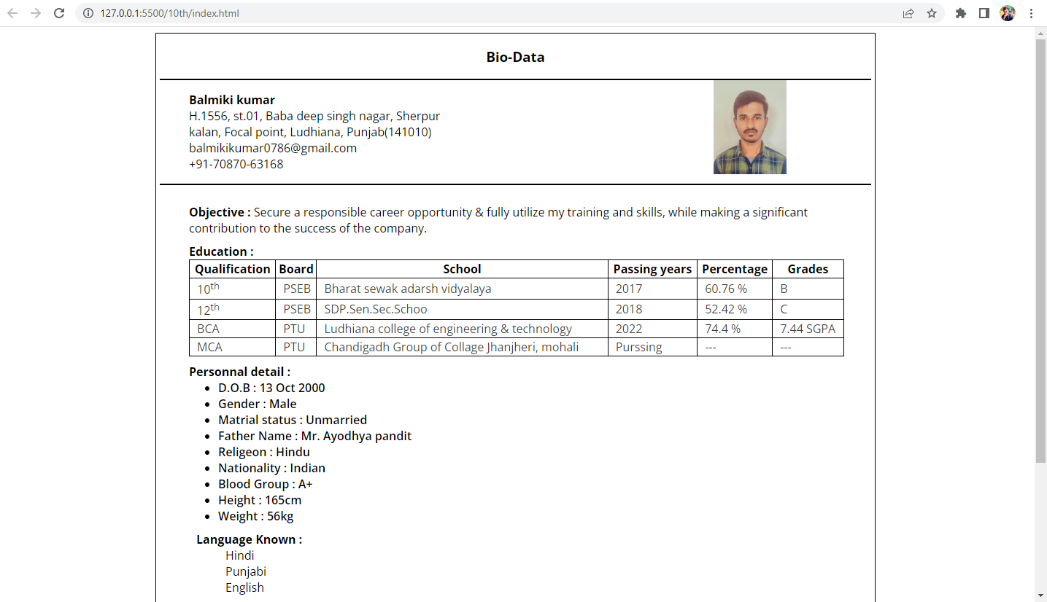



**11th Design front page of a hospital with different styles.**

<!DOCTYPE html>

<html>

<head>

    <title>Hospital</title>

    <link href="style.css" rel="stylesheet">

    <link href="../3rd/css/bootstrap.min.css" rel="stylesheet">

    <script src="../3rd/js/bootstrap.bundle.min.js"></script>

    <link href="//maxcdn.bootstrapcdn.com/font-awesome/4.7.0/css/font-awesome.min.css" rel="stylesheet">

</head>

<body>

    <div class="container-fluid top">

        <div class="row border">

            <div class="col-sm-7">

                <ul class="list list-unstyled nav ps-5">

                    <li class="nav-link"><a href="https://wa.me/917087063168?text=Webtechnology"><i class="fa fa-whatsapp"></i></a></li>

                    <li class="nav-link"><a href="https://facebook.com/balmikiii"><i class="fa fa-facebook-official"></i></a></li>

                    <li class="nav-link"><a href="https://instagram.com/balmikiii"><i class="fa fa-instagram"></i></a></li>

                    <li class="nav-link"><a href="https://in.linkedin.com/in/balmikikumar"><i class="fa fa-linkedin-square"></i></a></li>

                </ul>

            </div>

            <div class="col-sm-5 text-end">

                <ul class="nav pe-5">

                    <li class="nav-link"><a href="#"><i class="fa fa-map-marker me-3"></i>CGC Jhanjeri</a></li>

                    <li class="nav-link"><a href="mailto:balmikikumar0786@gmail.com"><i class="fa fa-envelope-o me-3"></i>balmikikumar0786@gmail.com</a></li>

                </ul>

            </div>

        </div>

    </div>

    <nav class="navbar navbar-expand-sm">

        <div class="container">

          <a class="navbar-brand" href="index.html">Hospital</a>

          <button class="navbar-toggler" type="button" data-bs-toggle="collapse" data-bs-target="#mynavbar">

            <span class="navbar-toggler-icon"></span>

          </button>

          <div class="collapse navbar-collapse" id="mynavbar">

            <ul class="navbar-nav me-auto text-end ms-5">

              <li class="nav-item ms-5">

                <a class="nav-link" href="index.html">Home</a>

              </li>

              <li class="nav-item">

                <a class="nav-link" href="#">Service</a>

              </li>

              <li class="nav-item">

                <a class="nav-link" href="#">Contact Us</a>

              </li>

              <li class="nav-item">

                <a class="nav-link btn btn-outline-danger" href="#">Register</a>

              </li>

            </ul>

            <div><i class="fa fa-search"></i></div>

          </div>

        </div>

      </nav>

      <div class="carou">

        <img  src="img/hospital1.jpg" width="100%"; height="600px">

        <div class="carousel-caption">

          <h3>Balmiki kumar</h3>

          <p class=" btn btn-outline-danger">Register</p>

        </div>

      </div>

      <div class="container about">

        <div class="row mt-5 pt-5 mb-5 pb-5">

            <div class="col-sm-6">

                <img src="img/building.jpg" class="rounded" width="100%"; height="auto" alt="holpita building">

            </div>

            <div class="col-sm-6">

                <p class="mt-3"><strong>-Welcome to Balmiki CGC</strong></p>

                <h4>We Can Create More Than You Expert</h4>

                <p>Thankyou contact to <strong>Balmiki Hospital</strong>  We have experence doctors. A hospital is a health care institution providing patient treatment with specialized health science and auxiliary healthcare staff and medical equipment</p>

                <div class="row">

                    <div class="col-sm-6"><p><strong>--</strong><b> Contribution</b></p>

                    <p class="ms-5">The Hospitals Contribution Fund of Australia, commonly referred to as HCF, is an Australian private health insurer headquartered in Sydney, New South Wales.</p>

                    <p class=" btn btn-danger ms-5">Register</p>

                    </div>

                    <div class="col-sm-6"><p><strong>--</strong><b> Artitecture</b></p>

                        <p class="ms-5">The Hospitals Contribution Fund of Australia, commonly referred to as HCF, is an Australian private health insurer headquartered in Sydney, New South Wales.</p>

                    </div>

                </div>

            </div>

        </div>

      </div>

      <div class="conteiner cont">

        <div class="row text-center">

            <div class="col-sm-3 d-grid">789</div>

            <div class="col-sm-3">158</div>

            <div class="col-sm-3">874</div>

            <div class="col-sm-3">987</div>

        </div>

      </div>

</body>

<footer>

  <div class="row ps-5 pt-5">

    <div class="col-sm-3">

      <ul class="list-unstyled list">

        <li><b class="text-white">Solution</b></li>

        <li>Control</li>

        <li>Scalability & Efficiency</li>

        <li>Suported by Expert</li>

        <li>Performannce & Security</li>

      </ul>

    </div>

    <div class="col-sm-3">

      <ul class="list-unstyled list">

        <li><b class="text-white">Resources</b></li>

        <li>Case Studies</li>

        <li>Blog</li>

        <li>I'm a Client</li>

      </ul>

    </div>

    <div class="col-sm-2">

      <ul class="list-unstyled list">

        <li><b class="text-white">Company</b></li>

        <li>About</li>

        <li>Careers</li>

        <li>Newssroom</li>

        <li>Contact Us</li>

      </ul>

    </div>

  <div class="col-sm-4">

    <div class="borderarea">

      <ul class="list-unstyled list u">

        <li class="pt-3">+91 70870-63168</li>

        <li class="red">balmikikumar0786@gmail.com</li>

        <li>CGC Jhanjeri</li>

      </ul>

      <ul class="list list-unstyled nav d-flex ps-5">

        <li class="nav-link"><a href="https://wa.me/917087063168?text=Webtechnology"><i class="fa fa-whatsapp me-3"></i></a></li>

        <li class="nav-link"><a href="https://facebook.com/balmikiii"><i class="fa fa-facebook-official me-3"></i></a></li>

        <li class="nav-link"><a href="https://instagram.com/balmikiii"><i class="fa fa-instagram me-3"></i></a></li>

        <li class="nav-link"><a href="https://in.linkedin.com/in/balmikikumar"><i class="fa fa-linkedin-square me-3"></i></a></li>

    </ul>

    </div>

  </div>

  </div>

  <p class="text-center">Balmiki @ 2235548</p>

</footer>

</html>

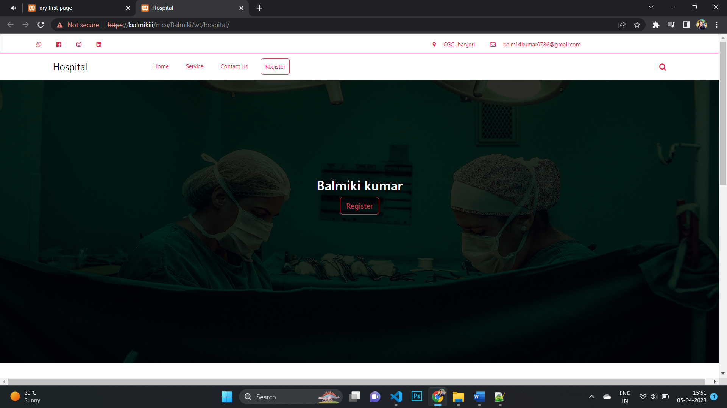

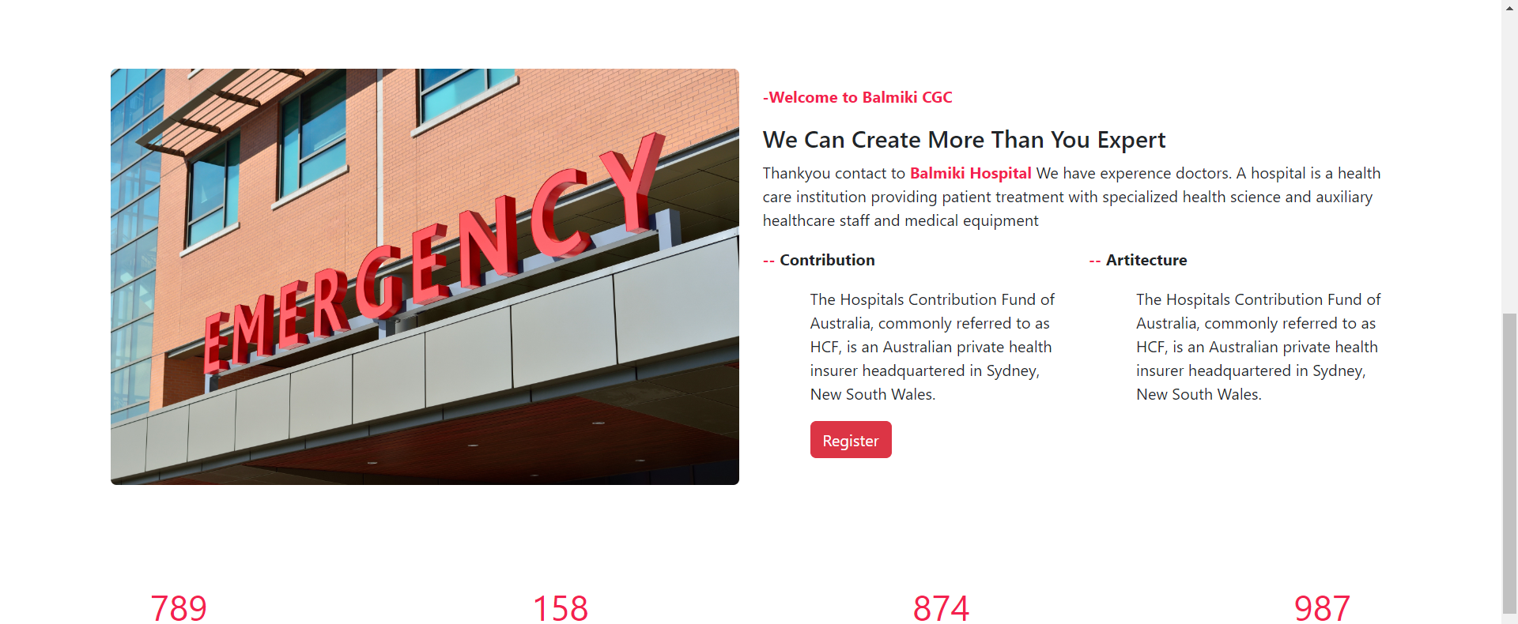

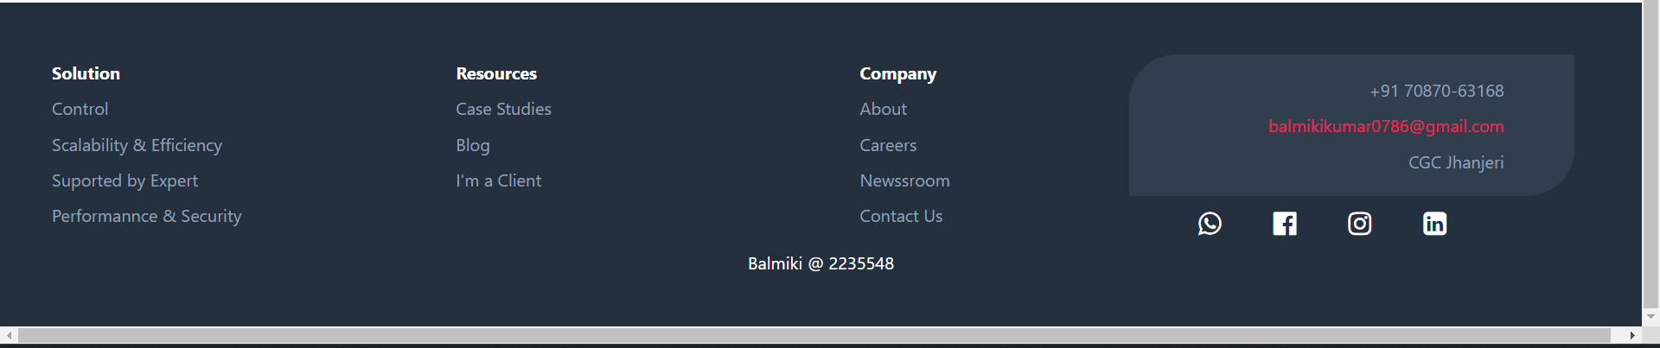

**12. Design a web page and display horizontally two different web pages at a time.**

<!DOCTYPE html>

<html>

    <title>two web frem</title>

</head>

<body>

    <div class="container">

        <iframe src="../3rd/letter.html"  width="100%" height="350px" frameborder="0"></iframe>

        <iframe src="../10th" width="100%" height="350px"  frameborder="0"></iframe>

    </div>

</body>

</html>

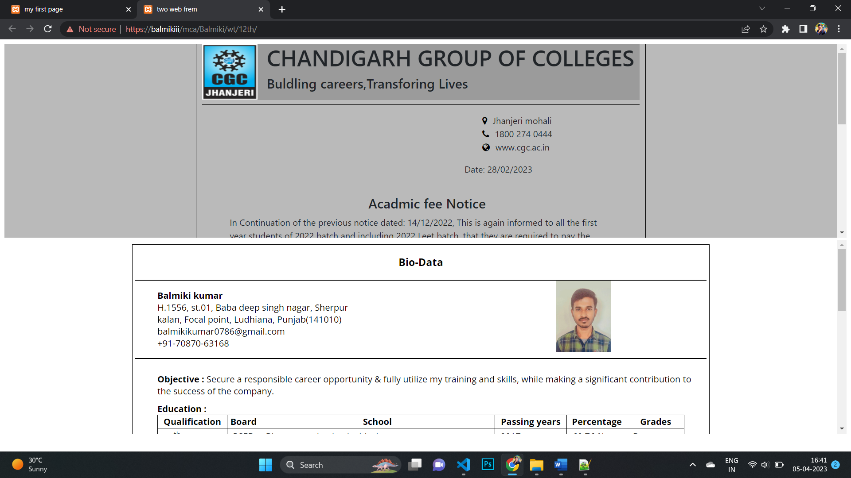

**13. Write a program to create a login form. On clicking the submit button, the user should get navigated to a profile page.**

<!DOCTYPE html>

<html>

<head>

    <title>login form</title>

    <link href="../3rd/css/bootstrap.min.css" rel="stylesheet">

    <script src="../3rd/js/bootstrap.bundle.min.js"></script>

    <link href="//maxcdn.bootstrapcdn.com/font-awesome/4.7.0/css/font-awesome.min.css" rel="stylesheet">

</head>

<style>

    .regit{

        width: 400px;

        margin-left: auto;

        margin-right: auto;

        border-radius: 5px;

        margin-top: 100px;

        box-shadow: 2px 2px 19px black;

    }

</style>

<body>

    <div class="container">

        <div class="regit pt-3 pb-3 pe-3 ps-3">

            <form class="form" action="../10th/">

                <div class="text-center h3">Login</div>

            <div class="input-group mb-3">

                <span class="input-group-text">@</span>

                <input type="text" class="form-control" id="user" placeholder="Username" name="usrname">

              </div>

              <div class="input-group mb-3">

                  <span class="input-group-text"><i class="fa fa-eye-slash"></i></span>

                <input type="text" class="form-control" id="pass" placeholder="Your password" name="email">

              </div>

            <div class="text-center pt-3">

                <input id="form" type="submit" onclick="db()" class="btn btn-dark">

            </div>

            </form>

        </div>

    </div>

</body>

<script>

    function db(){

        user = parseInt( document.getElementById("user").value);

        pass = parseInt( document.getElementById("pass").value);

        if (user == "Balmikiii"){

            if (pass == "2235548") {

                alert("Success");

            } else{

                alert("Try again");

            }

        } else {

            alert("wrong user and password");

        }}

        </script>

</html>

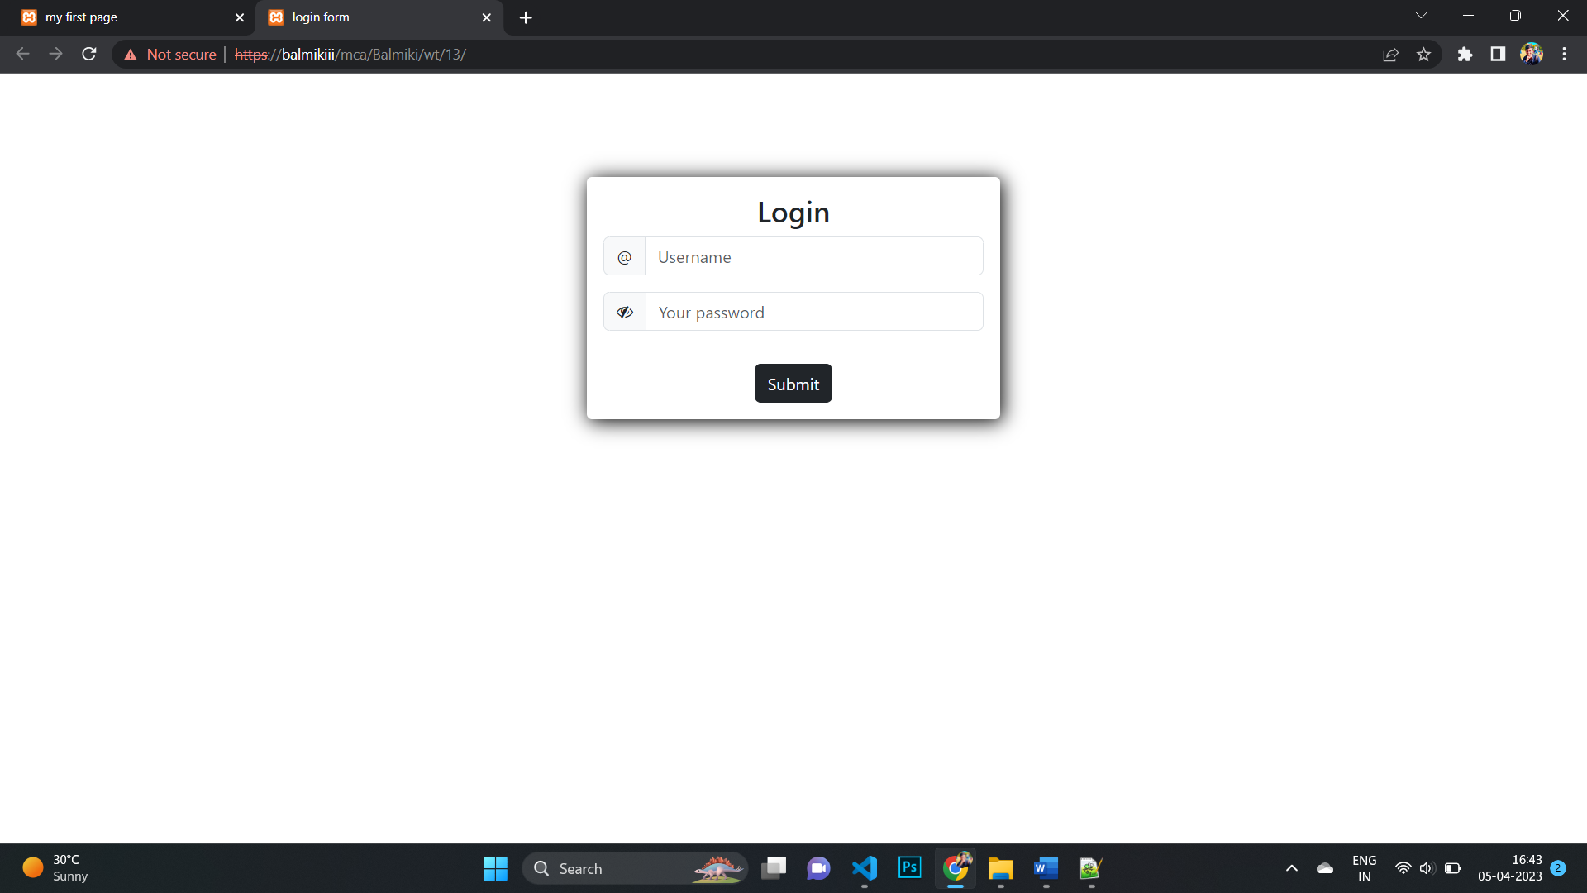

**14.Write a HTML code to create a Registration Form. On submitting the form, the user should be asked to login with the new credentials.**

<!DOCTYPE html>

<html>

<head>

    <title>login form</title>

    <link href="../3rd/css/bootstrap.min.css" rel="stylesheet">

    <script src="../3rd/js/bootstrap.bundle.min.js"></script>

    <link href="//maxcdn.bootstrapcdn.com/font-awesome/4.7.0/css/font-awesome.min.css" rel="stylesheet">

</head>

<style>

    .regit{

        width: 400px;

        margin-left: auto;

        margin-right: auto;

        border-radius: 5px;

        margin-top: 100px;

        box-shadow: 2px 2px 19px black;

    }

</style>

<body>

    <div class="container">

        <div class="regit pt-3 pb-3 pe-3 ps-3">

            <form class="form" action="balmiki.php" method="post">

                <div class="text-center h3">Regitation</div>

            <div>

                <lable>Name :</lable>

                <input type="text" class="form-control" name="name" placeholder="Enter your name" required>

            </div>

            <div class="pt-3">

                <lable>Contact :</lable>

                <input type="number" class="form-control" name="contact" placeholder="Enter your Mobile number" required>

            </div>

            <div class="pt-3">

                <lable>Email :</lable>

                <input type="email" class="form-control" name="email" placeholder="Enter your Email ID" required>

            </div>

            <div class="pt-3">

                <lable>Gender :</lable>

                <input type="radio" name="gender" value="male" required>Male

                <input type="radio" name="gender" value="Female" required>Female

            </div>

            <div class="pt-3">

                <label>Date of birth</label>

                <input type="date" class="form-control" name="dob" required>

            </div>

            <div class="row">

                <div class="pt-3 col-6">

                    <label>State</label>

                    <input type="text" class="form-control" name="state" placeholder="Yor states" required>

                </div>

                <div class="pt-3 col-6">

                    <label>City</label>

                    <input type="text" class="form-control" name="city" placeholder="Yor city" required>

                </div>

            </div>

            <div class="text-center pt-3">

                <input type="submit" class="btn btn-dark">

            </div>

            </form>

        </div>

    </div>

</body>

</html>

PHP Code

<!DOCTYPE html>

<html>

<head>

    <title>User information</title>

    <link href="../3rd/css/bootstrap.min.css" rel="stylesheet">

    <script src="../3rd/js/bootstrap.bundle.min.js"></script>

    <link href="//maxcdn.bootstrapcdn.com/font-awesome/4.7.0/css/font-awesome.min.css" rel="stylesheet">

</head>

<style>

    .regit{

        width: 400px;

        margin-left: auto;

        margin-right: auto;

        border-radius: 5px;

        margin-top: 100px;

        box-shadow: 2px 2px 19px black;

    }

</style>

<body>

    <div class="container">

        <div class="regit pt-3 pb-3 pe-3 ps-3">

        <div>

            <div class="text-center h3">About you</div>

            <div>

                <span>Name :</span>

                <?php echo $_POST["name"]; ?>

            </div>

            <div class="pt-3">

                <span>Number :</span>

                <?php echo $_POST["contact"]; ?>

            </div>

            <div class="pt-3">

                <span>Email :</span>

                <?php echo $_POST["email"]; ?>

            </div>

            <div class="pt-3">

                <span>Gender :</span>

                <?php echo $_POST["gender"]; ?>

            </div>

            <div class="pt-3">

                <label>Date of birth :</label>

                <?php echo $_POST["dob"]; ?>

            </div>

            <div class="pt-3">

                <label>Your State :</label>

                <?php echo $_POST["state"]; ?>

            </div>

            <div class="pt-3">

                <label>city :</label>

                <?php echo $_POST["city"]; ?>

            </div>

            </div>

        </div>

    </div>

</body>

</html>

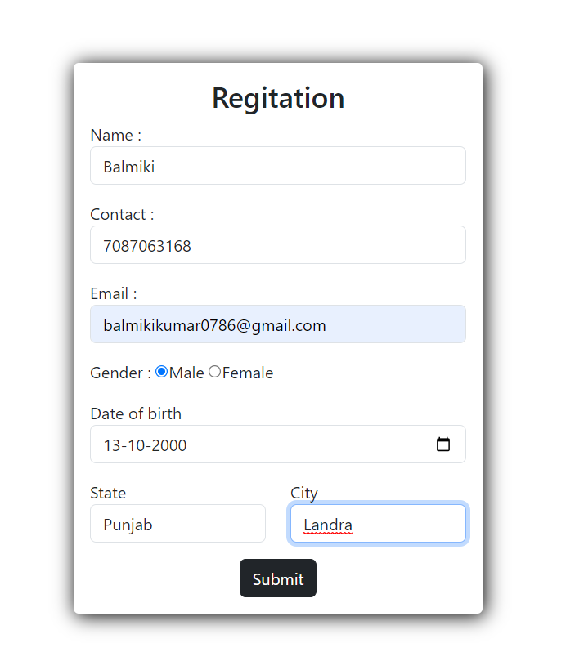

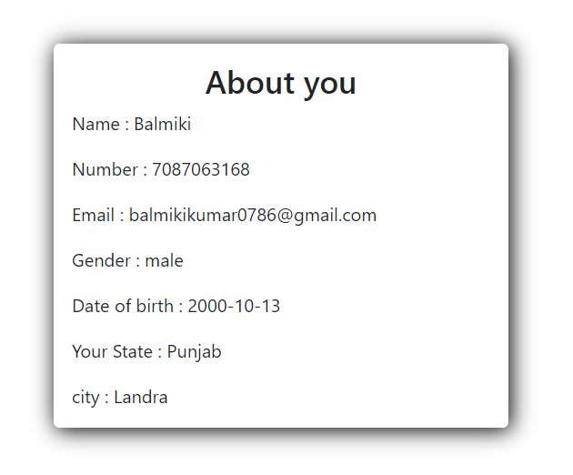

**15. Write a HTML code to create website in your college or department and create link for Tutorial of specific subject.**

<!DOCTYPE html>

<html>

<head>

    <title>Tutorial</title>

    <link href="style.css" rel="stylesheet">

    <link href="../3rd/css/bootstrap.min.css" rel="stylesheet">

    <script src="../3rd/js/bootstrap.bundle.min.js"></script>

    <link href="//maxcdn.bootstrapcdn.com/font-awesome/4.7.0/css/font-awesome.min.css" rel="stylesheet">

</head>

<body>

    <div class="container-fluid top">

        <div class="row border">

            <div class="col-sm-7">

                <ul class="list list-unstyled nav ps-5">

                    <li class="nav-link"><a href="https://wa.me/917087063168?text=Webtechnology"><i class="fa fa-whatsapp"></i></a></li>

                    <li class="nav-link"><a href="https://facebook.com/balmikiii"><i class="fa fa-facebook-official"></i></a></li>

                    <li class="nav-link"><a href="https://instagram.com/balmikiii"><i class="fa fa-instagram"></i></a></li>

                    <li class="nav-link"><a href="https://in.linkedin.com/in/balmikikumar"><i class="fa fa-linkedin-square"></i></a></li>

                </ul>

            </div>

            <div class="col-sm-5 text-end">

                <ul class="nav pe-5">

                    <li class="nav-link"><a href="#"><i class="fa fa-map-marker me-3"></i>CGC Jhanjeri</a></li>

                    <li class="nav-link"><a href="mailto:balmikikumar0786@gmail.com"><i class="fa fa-envelope-o me-3"></i>balmikikumar0786@gmail.com</a></li>

                </ul>

            </div>

        </div>

    </div>

    <nav class="navbar navbar-expand-sm">

        <div class="container">

          <a class="navbar-brand" href="index.html">Tutorial</a>

          <button class="navbar-toggler" type="button" data-bs-toggle="collapse" data-bs-target="#mynavbar">

            <span class="navbar-toggler-icon"></span>

          </button>

          <div class="collapse navbar-collapse" id="mynavbar">

            <ul class="navbar-nav me-auto text-end ms-5">

              <li class="nav-item ms-5">

                <a class="nav-link" href="index.html">Home</a>

              </li>

              <li class="nav-item">

                <a class="nav-link" href="#">Service</a>

              </li>

              <li class="nav-item">

                <a class="nav-link" href="#">Contact Us</a>

              </li>

              <li class="nav-item">

                <a class="nav-link btn btn-outline-danger" href="tutorial.html">Tutorial</a>

              </li>

            </ul>

            <div><i class="fa fa-search"></i></div>

          </div>

        </div>

      </nav>

      <div class="carou">

        <img  src="img/hospital1.jpg" width="100%"; height="600px">

        <div class="carousel-caption">

          <a href="tutorial.html"><p class=" btn btn-danger">Tutorial</p></a>

        </div>

      </div>

      <div class="container about">

        <div class="row mt-5 pt-5 mb-5 pb-5">

            <div class="col-sm-6">

                <img src="img/building.jpg" class="rounded" width="100%"; height="auto" alt="holpita building">

            </div>

            <div class="col-sm-6">

                <p class="mt-3"><strong>-Welcome to Balmiki CGC</strong></p>

                <h4>We Can Create More Than You Expert</h4>

                <p>Thankyou contact to <strong>Collage</strong>  We have experence Teachers. A Collage is a Best studay & knowleige provides to student. creat a bright future</p>

                <div class="row">

                    <div class="col-sm-6"><p><strong>--</strong><b> Contribution</b></p>

                    <p class="ms-5">an institution of higher learning, especially one providing a general or liberal arts education rather than technical or professional training. Compare university. a constituent unit of a university, furnishing courses of instruction in the liberal arts and sciences, usually leading to a bachelor's degree.</p>

                    <a href="tutorial.html"><p class=" btn btn-danger ms-5">Chek tutorials</p></a>

                    </div>

                    <div class="col-sm-6"><p><strong>--</strong><b> Artitecture</b></p>

                        <p class="ms-5">an institution of higher learning, especially one providing a general or liberal arts education rather than technical or professional training. Compare university. a constituent unit of a university, furnishing courses of instruction in the liberal arts and sciences, usually leading to a bachelor's degree.</p>

                    </div>

                </div>

            </div>

        </div>

      </div>

      <div class="conteiner cont">

        <div class="row text-center">

            <div class="col-sm-3 d-grid">789</div>

            <div class="col-sm-3">158</div>

            <div class="col-sm-3">874</div>

            <div class="col-sm-3">987</div>

        </div>

      </div>

</body>

<footer>

  <div class="row ps-5 pt-5">

    <div class="col-sm-3">

      <ul class="list-unstyled list">

        <li><b class="text-white">Solution</b></li>

        <li>Control</li>

        <li>Scalability & Efficiency</li>

        <li>Suported by Expert</li>

        <li>Performannce & Security</li>

      </ul>

    </div>

    <div class="col-sm-3">

      <ul class="list-unstyled list">

        <li><b class="text-white">Resources</b></li>

        <li>Case Studies</li>

        <li>Blog</li>

        <li>I'm a Client</li>

      </ul>

    </div>

    <div class="col-sm-2">

      <ul class="list-unstyled list">

        <li><b class="text-white">Company</b></li>

        <li>About</li>

        <li>Careers</li>

        <li>Newssroom</li>

        <li>Contact Us</li>

      </ul>

    </div>

  <div class="col-sm-4">

    <div class="borderarea">

      <ul class="list-unstyled list u">

        <li class="pt-3">+91 70870-63168</li>

        <li class="red">balmikikumar0786@gmail.com</li>

        <li>CGC Jhanjeri</li>

      </ul>

      <ul class="list list-unstyled nav d-flex ps-5">

        <li class="nav-link"><a href="https://wa.me/917087063168?text=Webtechnology"><i class="fa fa-whatsapp me-3"></i></a></li>

        <li class="nav-link"><a href="https://facebook.com/balmikiii"><i class="fa fa-facebook-official me-3"></i></a></li>

        <li class="nav-link"><a href="https://instagram.com/balmikiii"><i class="fa fa-instagram me-3"></i></a></li>

        <li class="nav-link"><a href="https://in.linkedin.com/in/balmikikumar"><i class="fa fa-linkedin-square me-3"></i></a></li>

    </ul>

    </div>

  </div>

  </div>

  <p class="text-center">Balmiki @ 2235548</p>

</footer>

</html>

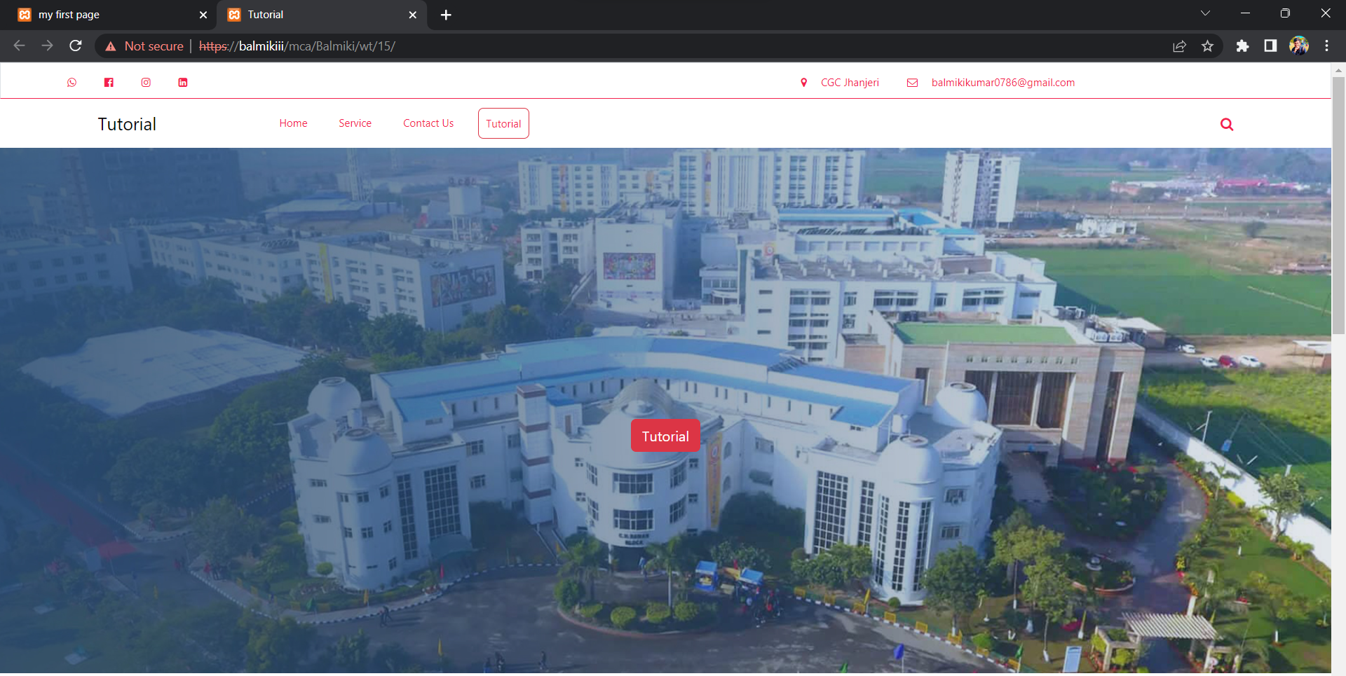



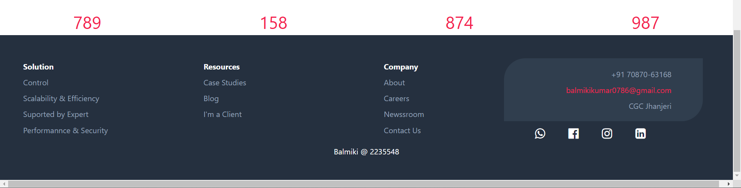

<!DOCTYPE html>

<html>

<head>

    <title>tutoria video</title>

    <link href="../3rd/css/bootstrap.min.css" rel="stylesheet">

    <script src="../3rd/js/bootstrap.bundle.min.js"></script>

    <link href="//maxcdn.bootstrapcdn.com/font-awesome/4.7.0/css/font-awesome.min.css" rel="stylesheet">

    <style>

        .g{

            display: flex;

        }

    </style>

</head>

<body>

    <div class="g">

        <div class="card">

            <div class="card-image-top">

                <iframe width="300" height="200" src="https://www.youtube.com/embed/l7YBJZe0QAU" class="ms-5 mt-5" frameborder="0" allow="accelerometer; autoplay; clipboard-write; encrypted-media; gyroscope; picture-in-picture; web-share" allowfullscreen></iframe>

            </div>

            <div class="card-body">

            <p>Build an Eye-catching Login Form | HTML & CSS Only</p>

            </div>

        </div>

        <div class="card">

            <div class="card-image-top">

                <iframe width="300" height="200" class="ms-5 mt-5" src="https://www.youtube.com/embed/1Aq9OJuS3ok" title="YouTube video player" frameborder="0" allow="accelerometer; autoplay; clipboard-write; encrypted-media; gyroscope; picture-in-picture; web-share" allowfullscreen></iframe>

            </div>

            <div class="card-body">

            <p>CSS Animation Effects | Html CSS Only Html CSS Only</p>

            </div>

        </div>

        <div class="card">

            <div class="card-image-top">

                <iframe width="300" height="200" class="ms-5 mt-5" src="https://www.youtube.com/embed/Tkp3FDgOueM" title="YouTube video player" frameborder="0" allow="accelerometer; autoplay; clipboard-write; encrypted-media; gyroscope; picture-in-picture; web-share" allowfullscreen></iframe>

            </div>

            <div class="card-body">

            <p>Build a Complete Responsive Personal Portfolio Website</p>

            </div>

        </div>

    </div>

    <div class="g">

        <div class="card">

            <div class="card-image-top">

                <iframe width="300" height="200" src="https://www.youtube.com/embed/l7YBJZe0QAU" class="ms-5 mt-5" frameborder="0" allow="accelerometer; autoplay; clipboard-write; encrypted-media; gyroscope; picture-in-picture; web-share" allowfullscreen></iframe>

            </div>

            <div class="card-body">

            <p>Build an Eye-catching Login Form | HTML & CSS Only</p>

            </div>

        </div>

        <div class="card">

            <div class="card-image-top">

                <iframe width="300" height="200" class="ms-5 mt-5" src="https://www.youtube.com/embed/1Aq9OJuS3ok" title="YouTube video player" frameborder="0" allow="accelerometer; autoplay; clipboard-write; encrypted-media; gyroscope; picture-in-picture; web-share" allowfullscreen></iframe>

            </div>

            <div class="card-body">

            <p>CSS Animation Effects | Html CSS Only Html CSS Only</p>

            </div>

        </div>

        <div class="card">

            <div class="card-image-top">

                <iframe width="300" height="200" class="ms-5 mt-5" src="https://www.youtube.com/embed/Tkp3FDgOueM" title="YouTube video player" frameborder="0" allow="accelerometer; autoplay; clipboard-write; encrypted-media; gyroscope; picture-in-picture; web-share" allowfullscreen></iframe>

            </div>

            <div class="card-body">

            <p>Build a Complete Responsive Personal Portfolio Website</p>

            </div>

        </div>

    </div>

</body>

</html>

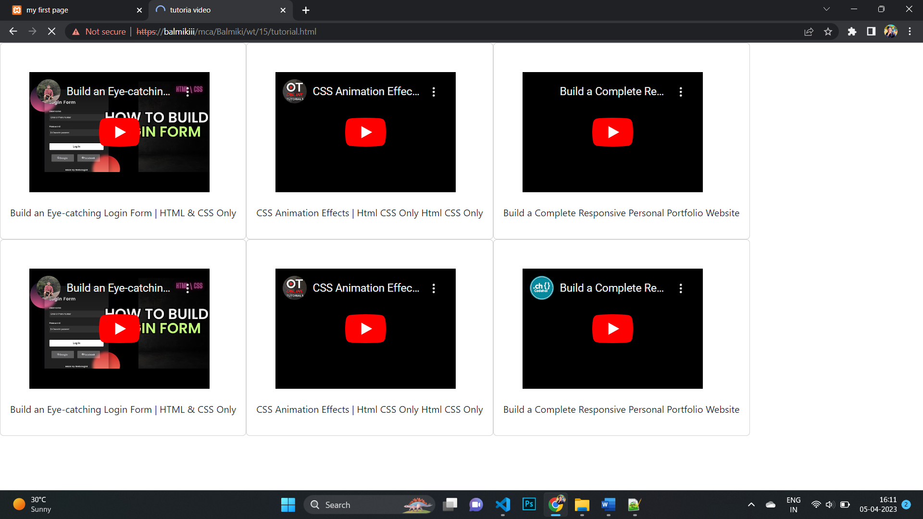

**16. Write a program to perform following operations on two numbers input by the user: Addition 2) Subtraction 3) Multiplication 4) Division**

<!DOCTYPE html>

<head>

    <title>Input operation</title>

    <link href="../3rd/css/bootstrap.min.css" rel="stylesheet">

    <script src="../3rd/js/bootstrap.bundle.min.js"></script>

    <link href="//maxcdn.bootstrapcdn.com/font-awesome/4.7.0/css/font-awesome.min.css" rel="stylesheet">

<style>

    .regit{

        width: 400px;

        margin-left: auto;

        margin-right: auto;

        border-radius: 5px;

        margin-top: 100px;

        box-shadow: 2px 2px 19px black;

    }

    #res{

        display: none;

    }

</style>

</head>

<body>

        <div class="regit pt-3 pb-3 pe-3 ps-3">

                <div class="text-center h4">Operation</div>

                <input type="number" id="one" class="form-control mb-3" placeholder="Enter any number">

              <div class="input-group mb-3">

                <input type="Enter again" id="two" class="form-control" placeholder="Number">

              </div>

              <div id="res">

                  Addition = <input class="form-control" id="add"><br/>

                  Subtraction = <input class="form-control" id="subtract"><br/>

                  Multiplication = <input class="form-control" id="multiply"><br/>

                  Division = <input class="form-control" id="divide">

                </div>

                <div class="text-center pt-3">

                    <button onclick="fun()" class="btn btn-dark">submit</button>

                </div>

        </div>

</body>

<script>

    var numOne, numTwo, res, temp;

    function fun()

    {

      numOne = parseInt(document.getElementById("one").value);

      numTwo = parseInt(document.getElementById("two").value);

      if(numOne && numTwo)

      {

        temp = document.getElementById("res");

        temp.style.display = "block";

        res = numOne + numTwo;

        document.getElementById("add").value = res;

        res = numOne - numTwo;

        document.getElementById("subtract").value = res;

        res = numOne * numTwo;

        document.getElementById("multiply").value = res;

        res = numOne / numTwo;

        document.getElementById("divide").value = res;

      }

    }

    </script>

</html>

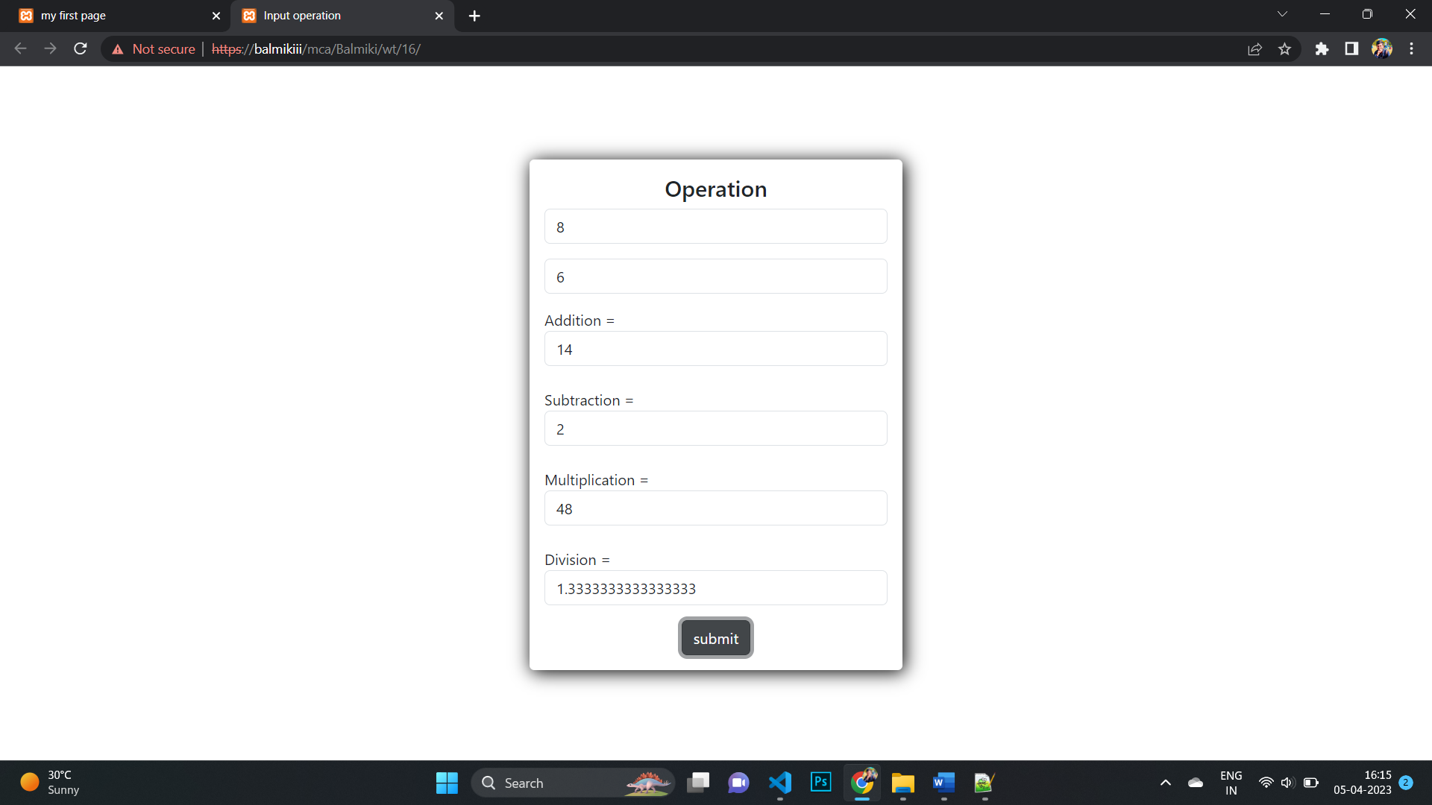

**17. Design a program to solve quadratic equations**

<!DOCTYPE html>

<head>

    <title>Input operation</title>

    <link href="../3rd/css/bootstrap.min.css" rel="stylesheet">

    <script src="../3rd/js/bootstrap.bundle.min.js"></script>

    <link href="//maxcdn.bootstrapcdn.com/font-awesome/4.7.0/css/font-awesome.min.css" rel="stylesheet">

<style>

    .regit{

        width: 400px;

        margin-left: auto;

        margin-right: auto;

        border-radius: 5px;

        margin-top: 100px;

        box-shadow: 2px 2px 19px black;

    }

</style>

</head>

<body>

    <div class="regit pt-3 pb-3 pe-3 ps-3">

        <div class="text-center h4">quadratic equations</div>

            <input type="number" id="a" class="form-control mb-3" placeholder="quadratic equations number">

            <input type="number" id="b" class="form-control mb-3" placeholder="quadratic equations number">

            <input type="number" id="c" class="form-control mb-3" placeholder="quadratic equations number">

            <p id="x"></p>

            <p id="y"></p>

        <div class="text-center pt-3">

            <button onclick="Balmiki()" class="btn btn-dark">Root</button>

        </div>

    </div>

    <script>

        function Balmiki() {

        let a = parseInt( document.getElementById("a").value);

        let b = parseInt( document.getElementById("b").value);

        let c = parseInt( document.getElementById("c").value);

        let discriminant = b*b - 4*a*c;

        let x = (-b+ Math.sqrt(discriminant))/2;

        let y = (-b- Math.sqrt(discriminant))/2;

        document.getElementById("x").innerHTML = "Your first root is"+x ;

        document.getElementById("y").innerHTML = "your second root is"+y ;

        }

    </script>

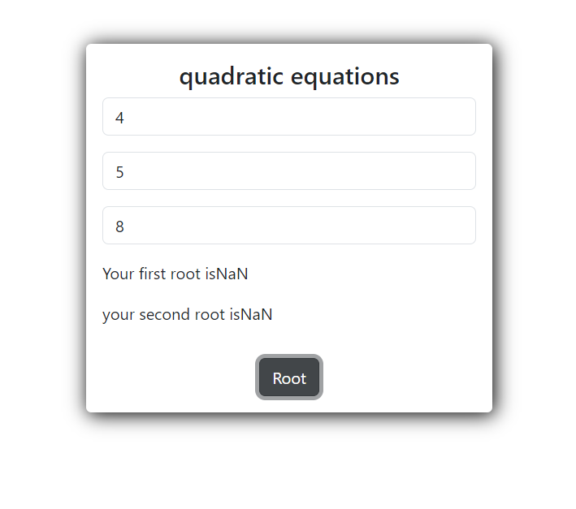

</body>

</html>

**18. Write a program to determine greatest number of three numbers.**

<!DOCTYPE html>

<head>

    <title>Input operation</title>

    <link href="../3rd/css/bootstrap.min.css" rel="stylesheet">

    <script src="../3rd/js/bootstrap.bundle.min.js"></script>

    <link href="//maxcdn.bootstrapcdn.com/font-awesome/4.7.0/css/font-awesome.min.css" rel="stylesheet">

    <style>

        .regit{

            width: 400px;

            margin-left: auto;

            margin-right: auto;

            border-radius: 5px;

            margin-top: 100px;

            box-shadow: 2px 2px 19px black;

        }

        #res{

            display: none;

        }

    </style>

</head>

<body>

    <div class="regit pt-3 pb-3 pe-3 ps-3">

        <div class="text-center h4">largest Number find</div>

            <input type="number" id="one" class="form-control mb-3" placeholder="Enter any number">

        <div class="input-group mb-3">

            <input type="Enter again" id="two" class="form-control" placeholder="Number">

        </div>

        <div class="input-group mb-3">

            <input type="Enter again" id="three" class="form-control" placeholder="Number">

        </div>

        <div class="text-center pt-3">

            <button onclick="largest()" class="btn btn-dark">Check</button>

        </div>

    </div>

    <script>

        function largest()

        {

            var num1, num2, num3;

            num1 = Number(document.getElementById("one").value);

            num2 = Number(document.getElementById("two").value);

            num3 = Number(document.getElementById("three").value);

            if(num1>num2 && num1>num3)

            {

                window.alert(num1+"-is greatest");

            }

            else if(num2>num1 && num2>num3)

            {

                window.alert(num2+"-is greatst");

            }

            else if(num3>num1 && num3>num1)

            {

                window.alert(num3+" is greatest");

            }

        }

    </script>

</body>

</html>

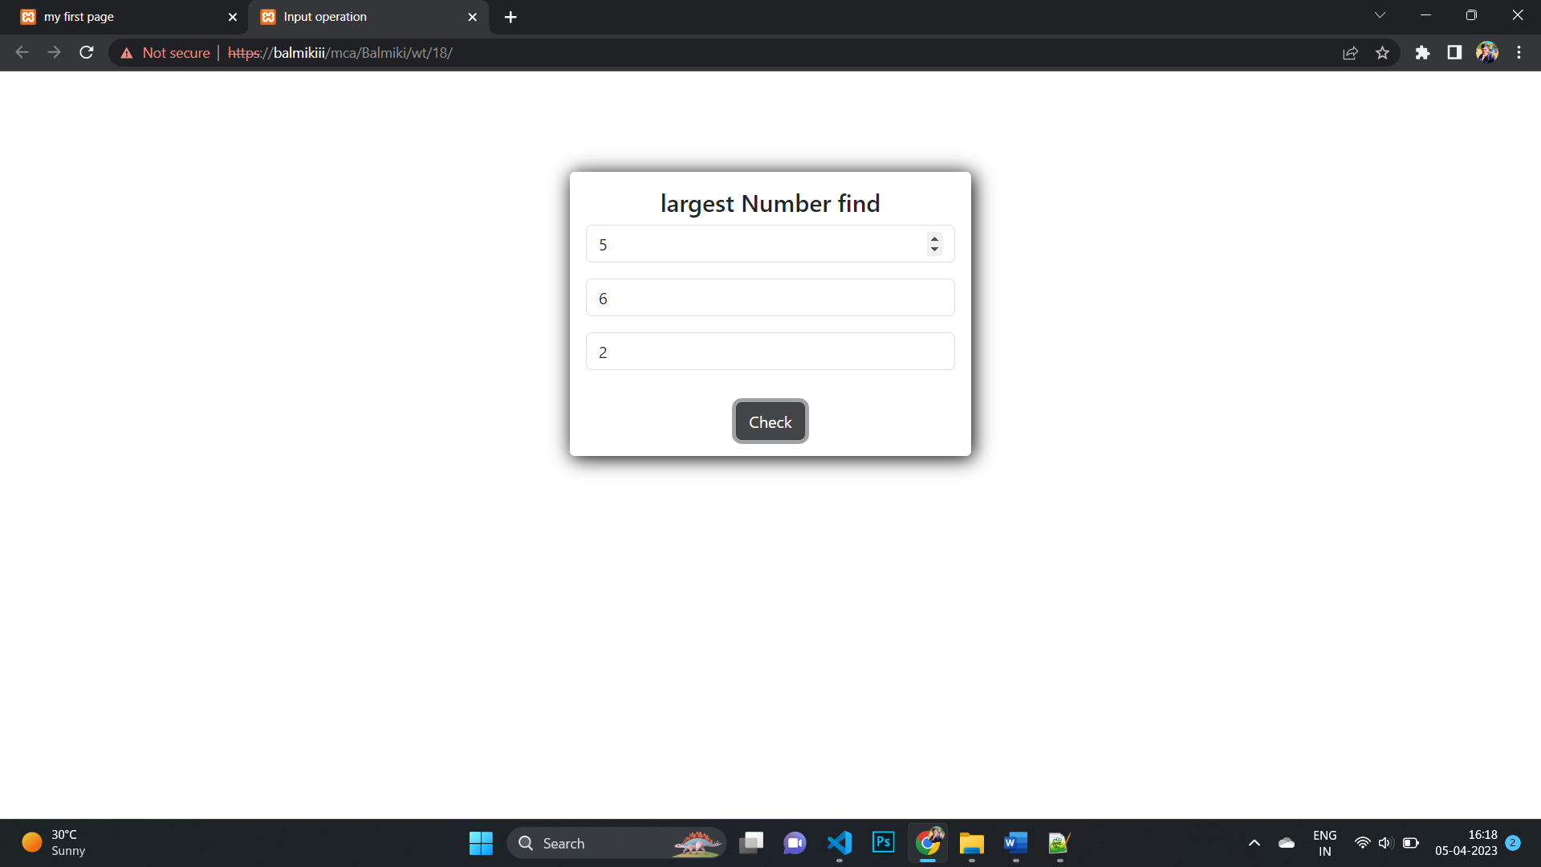

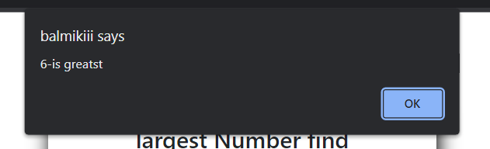

**19. Write a script to compute, the Average and Grade of students marks.**

<!DOCTYPE html>

<html>

<head>

    <title>Average</title>

    <link href="../3rd/css/bootstrap.min.css" rel="stylesheet">

    <script src="../3rd/js/bootstrap.bundle.min.js"></script>

    <link href="//maxcdn.bootstrapcdn.com/font-awesome/4.7.0/css/font-awesome.min.css" rel="stylesheet">

    <style>

        .regit{

        width: 791px;

        margin-left: auto;

        margin-right: auto;

        border-radius: 5px;

        margin-top: 100px;

        box-shadow: 2px 2px 19px black;

        }

    </style>

</head>

<body>

    <div class="regit pt-3 pb-3 pe-3 ps-3">

        <div class="text-center h4 pb-3">PTU Ressult</div>

        <div class="row">

            <div class="col-sm-6">

                <h4 class="text-center">Theory</h4>

                <div class="input-group mb-3">

                    <span class="input-group-text">Out of 70</span>

                    <input type="number" class="form-control" placeholder="Web Technology" id="wt"/>

                </div>

                <div class="input-group mb-3">

                    <span class="input-group-text">Out of 70</span>

                    <input type="number" class="form-control" placeholder="Information of Technology" id="isl"/>

                </div>

                <div class="input-group mb-3">

                    <span class="input-group-text">Out of 70</span>

                    <input type="number" class="form-control" placeholder="Linux" id="linux"/>

                </div>

                <div class="input-group mb-3">

                    <span class="input-group-text">Out of 70</span>

                    <input type="number" class="form-control" placeholder="Java" id="java" />

                </div>

                <div class="input-group mb-3">

                    <span class="input-group-text">Out of 70</span>

                    <input type="number" class="form-control" placeholder="Data Design & Algorithm" id="dda"/>

                </div>

            </div>

            <div class="col-sm-6">

                <h4 class="text-center">Lab</h4>

                <div class="input-group mb-3">

                    <span class="input-group-text">Out of 30</span>

                    <input type="number" class="form-control" placeholder="Java Lab" id="javalab"/>

                </div>

                <div class="input-group mb-3">

                    <span class="input-group-text">Out of 30</span>

                    <input type="number" class="form-control" placeholder="Lunux lab" id="linuxlab"/>

                </div>

                <div class="input-group mb-3">

                    <span class="input-group-text">Out of 30</span>

                    <input type="number" class="form-control" placeholder="web Technology lab" id="wtl"/>

                </div>

            </div>

        </div>

        <div class="input-group mb-3 showdata">

            <p id="showdata"></p>

        </div>

        <div class="text-center pt-3">

            <button onclick="calculate()" class="btn btn-dark">submit</button>

        </div>

    </div>

    <script>

        const calculate = () => {

        let wt = document.querySelector("#wt").value;

        let isl = document.querySelector("#isl").value;

        let linux = document.querySelector("#linux").value;

        let java = document.querySelector("#java").value;

        let dda = document.querySelector("#dda").value;

        let javalab = document.querySelector("#javalab").value;

        let linuxlab = document.querySelector("#linuxlab").value;

        let wtl = document.querySelector("#wtl").value;

        let grades = "";

        let totalgrades = parseFloat(wt) + parseFloat(isl) + parseFloat(linux) + parseFloat(java) + parseFloat(dda) + parseFloat(javalab) + parseFloat(linuxlab) + parseFloat(wtl);

        let percentage = (totalgrades / 570) * 100;

        if (percentage <= 99 && percentage >= 90) {

            grades = "A+";

        } else if (percentage == 100) {

            grades = "O";

        } else if (percentage <= 89 && percentage >= 80) {

            grades = "A";

        } else if (percentage <= 79 && percentage >= 70) {

            grades = "B+";

        } else if (percentage <= 69 && percentage >= 60) {

            grades = "B";

        } else if (percentage <= 59 && percentage >= 50) {

            grades = "C";

        } else if (percentage <= 49 && percentage >= 40) {

            grades = "P";

        } else {

            grades = "F";

        }

        if (wt == "" || isl == "" || linux == "" || java == "" || dda == "" || javalab == "" || linuxlab == "" || wtl == "") {

            document.querySelector("#showdata").innerHTML = "Please enter all the fields";

        } else {

            if (percentage >= 33) {

            document.querySelector(

                "#showdata"

            ).innerHTML =` <mark class="bg-success">Out of 570 your total is ${totalgrades} and percentage is ${percentage}%. Your is ${grades}. You are Pass.</mark> `;

            } else {

            document.querySelector("#showdata").innerHTML =` <mark class="bg-danger">Out of 570 your total is ${totalgrades} and percentage is ${percentage}%. Your grade is ${grades}. You are Fail.</mark> `;

            }

        }

        };

    </script>

</body>

</html>

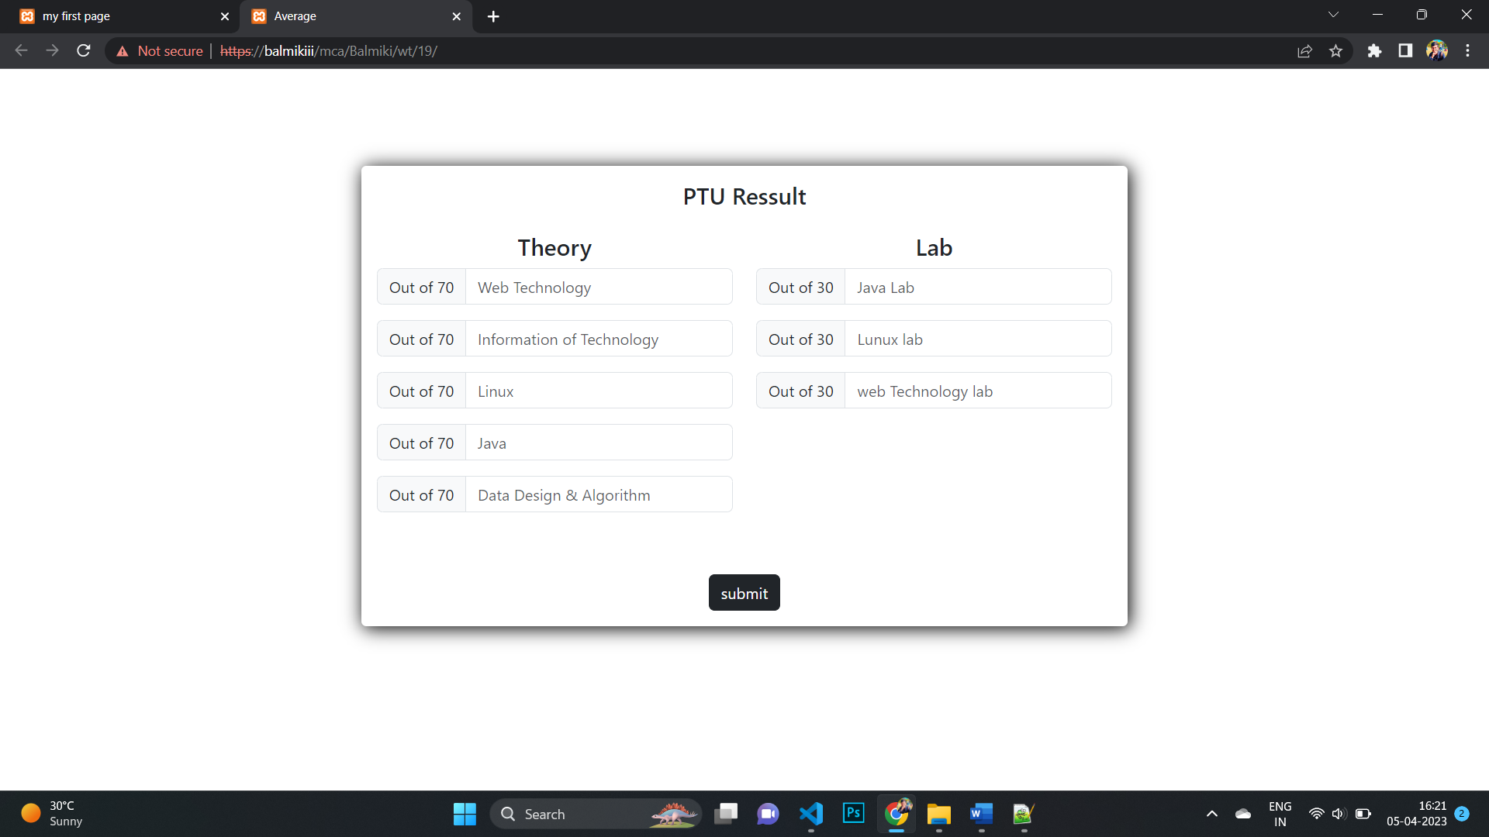

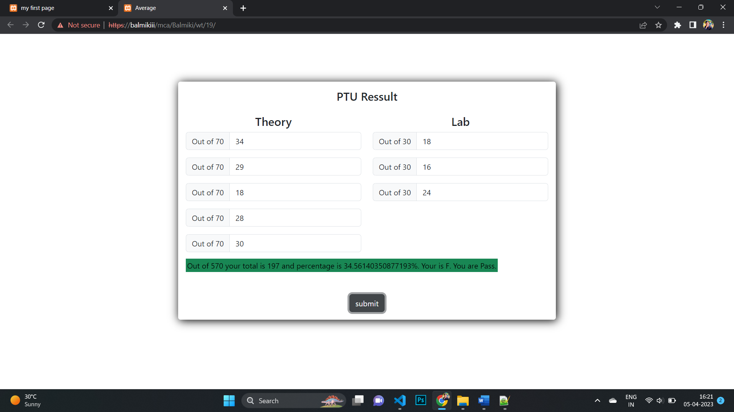

**20.Design a scientific calculator and make event for each button using scripting language.**

<html>

<head>

<title>calculator</title>

<style>

    *{

        box-sizing: border-box;

        -webkit-box-sizing: border-box;

        -moz-box-sizing: border-box;

    }

    .wrap{

        width: 374px;

        margin: auto;

        margin-top: 150px;

        padding: 15px;

        box-shadow: 5px 5px 11px black;

        background-color: #a0d0ea;

    }

    input[type=text]{

        width: 100%;

        padding: 10px;

        font-size: 22px;

        font-weight: bold;

        margin-top: 10px;

        border-radius: 5px;

        border: 1px solid #a0d0ea;

    }

    input[type=button]

    {

        width: 67px;

        padding: 16px;

        font-size: 22pz;

        font-weight: bold;

        border-radius: 5px;

        background-color: #efefef;

        color: rgb(0, 0, 0);

        border: 1px solid #a0d0ea;

        margin: 8px;

    }

    .cle{

        background-color: #fe9fa9 !important;

    }

    .ope{

        background-color: #efff93 !important;

    }

</style>

</head>

<body>

<div class ="wrap">

<form name ="cal">

<input type ="text" name ="display"><br>

<br>

<input type="button" value="9" onclick="cal.display.value+='9'">

<input type="button" value="8" onclick="cal.display.value+='8'">

<input type="button" value="7" onclick="cal.display.value+='7'">

<input type="button" class="ope" value="+" onclick="cal.display.value+='+'">

<br><br>

<input type="button" value="6" onclick="cal.display.value+='6'">

<input type="button" value="5" onclick="cal.display.value+='5'">

<input type="button" value="4" onclick="cal.display.value+='4'">

<input type="button" class="ope" value="-" onclick="cal.display.value+='-'">

<br><br>

<input type="button" value="3" onclick="cal.display.value+='3'">

<input type="button" value="2" onclick="cal.display.value+='2'">

<input type="button" value="1" onclick="cal.display.value+='1'">

<input type="button" class="ope" value="*" onclick="cal.display.value+='*'">

<br><br>

<input type="button" value="C" onclick="cal.display.value= ''" class="cle">

<input type="button" value="0" onclick="cal.display.value+='0'">

<input type="button" value="=" onclick="cal.display.value  =eval(cal.display.value)">

<input type="button" class="ope" value="/" onclick="cal.display.value+='/'">

<br>

</form>

</div>

</body>

</html>

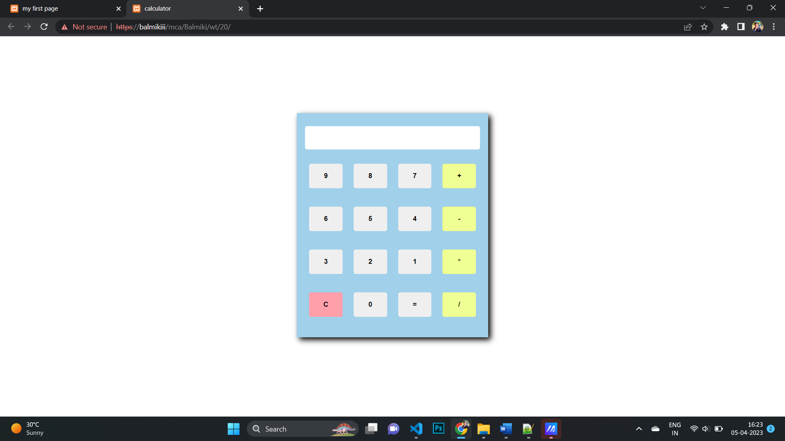

**21. Write a script to check whether a number is even or odd?**

<!DOCTYPE html>

<head>

    <title>Input operation</title>

    <link href="../3rd/css/bootstrap.min.css" rel="stylesheet">

    <script src="../3rd/js/bootstrap.bundle.min.js"></script>

    <link href="//maxcdn.bootstrapcdn.com/font-awesome/4.7.0/css/font-awesome.min.css" rel="stylesheet">

<style>

    .regit{

        width: 400px;

        margin-left: auto;

        margin-right: auto;

        border-radius: 5px;

        margin-top: 100px;

        box-shadow: 2px 2px 19px black;

    }

</style>

</head>

<body>

    <div class="regit pt-3 pb-3 pe-3 ps-3">

        <div class="text-center h4">Check even or odd</div>

            <input type="number" id="num" class="form-control mb-3" placeholder="Enter any number">

            <p id="resPara" style="display:none">It's <span id="res"></span> Number</p>

        <div class="text-center pt-3">

            <button onclick="fun()" class="btn btn-dark">submit</button>

        </div>

    </div>

<script>

    var num, temp;

    function fun(){

        num = parseInt(document.getElementById("num").value);

        if(num){

            temp = document.getElementById("resPara");

            temp.style.display = "block";

        if(num%2==0)

            document.getElementById("res").innerHTML = "Even";

        else

            document.getElementById("res").innerHTML = "Odd";

        }

    }

</script>

</body>

</html>

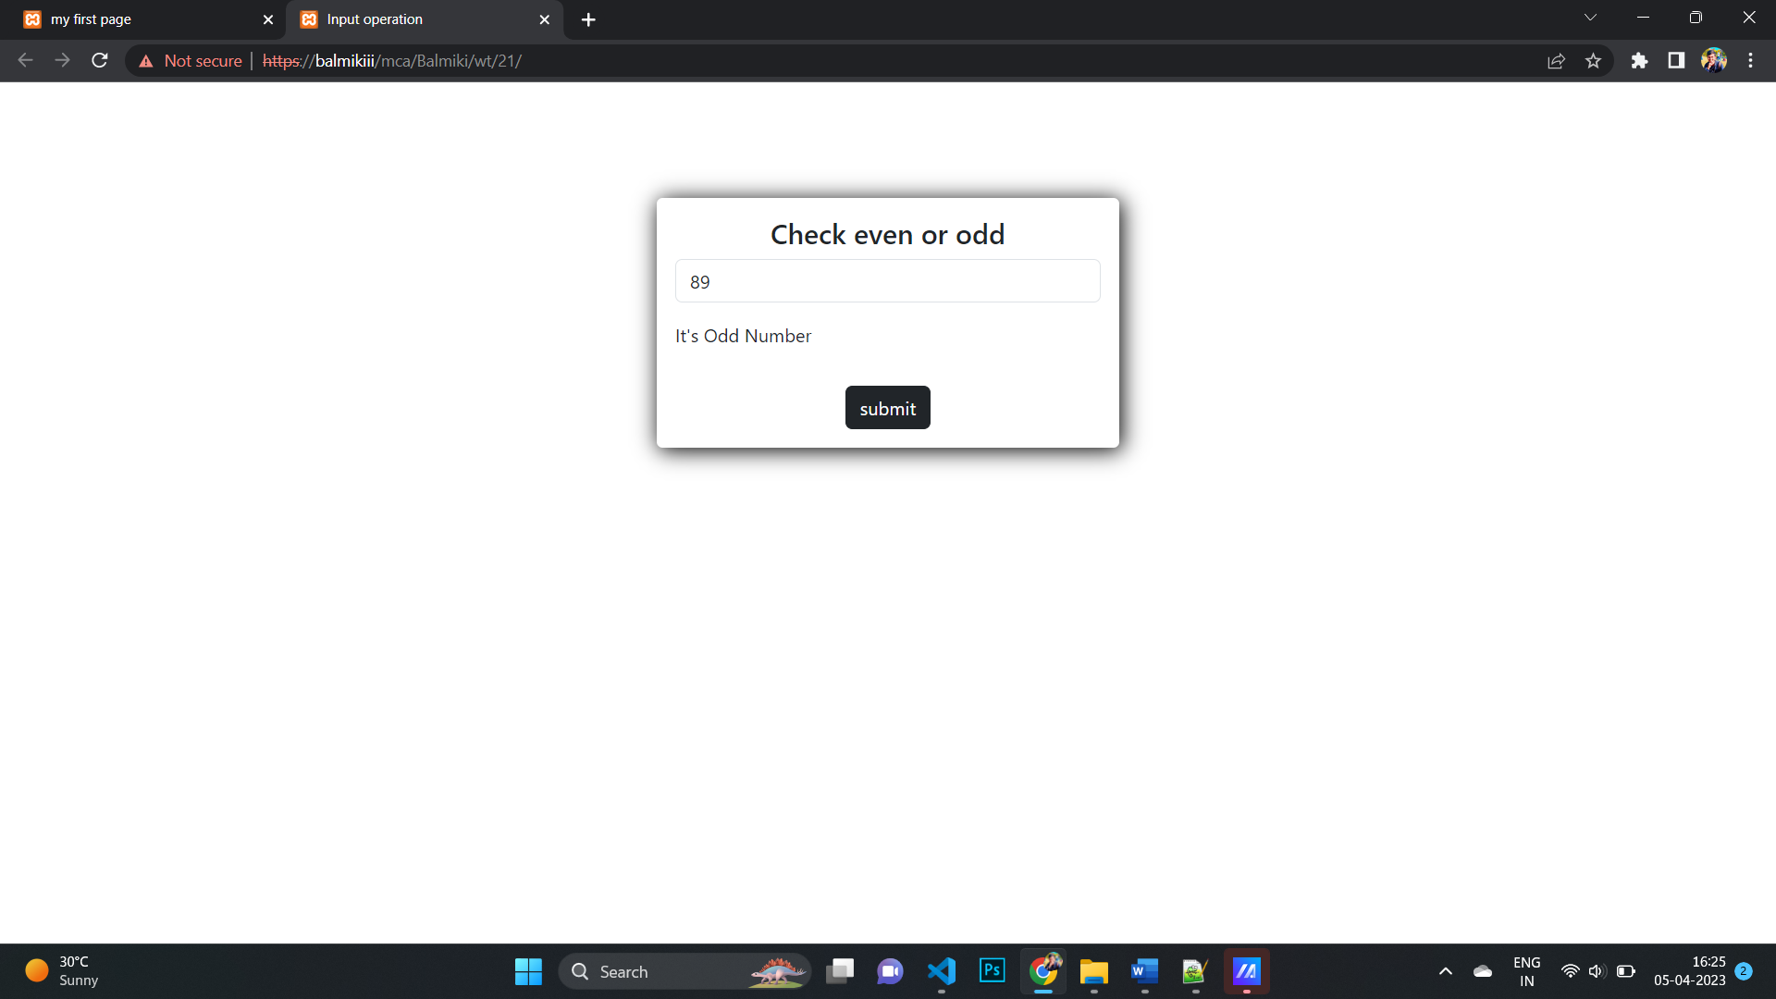

**22. Write a program to show whether a number is prime or not?**

<!DOCTYPE html>

<head>

    <title>Prime number</title>

    <link href="../3rd/css/bootstrap.min.css" rel="stylesheet">

    <script src="../3rd/js/bootstrap.bundle.min.js"></script>

    <link href="//maxcdn.bootstrapcdn.com/font-awesome/4.7.0/css/font-awesome.min.css" rel="stylesheet">

<style>

    .regit{

        width: 400px;

        margin-left: auto;

        margin-right: auto;

        border-radius: 5px;

        margin-top: 100px;

        box-shadow: 2px 2px 19px black;

    }

</style>

</head>

<body>

    <div class="regit pt-3 pb-3 pe-3 ps-3">

        <div class="text-center h4">Prime or not</div>

            <input type="number" id="num" class="form-control mb-3" placeholder="Enter any number">

            <p id="resPara" style="display:none">It's <span id="res"></span> Number</p>

        <div class="text-center pt-3">

            <button onclick="p()" class="btn btn-dark">submit</button>

        </div>

    </div>

    <script type="text/javascript">

        function p() {

            var n, i, flag = true;

            n = parseInt(document.getElementById("num").value);

            n = parseInt(n)

            for(i = 2; i <= n - 1; i++)

                if (n % i == 0) {

                    flag = false;

                    break;

                }

            if (flag == true)

                alert(n + " is prime");

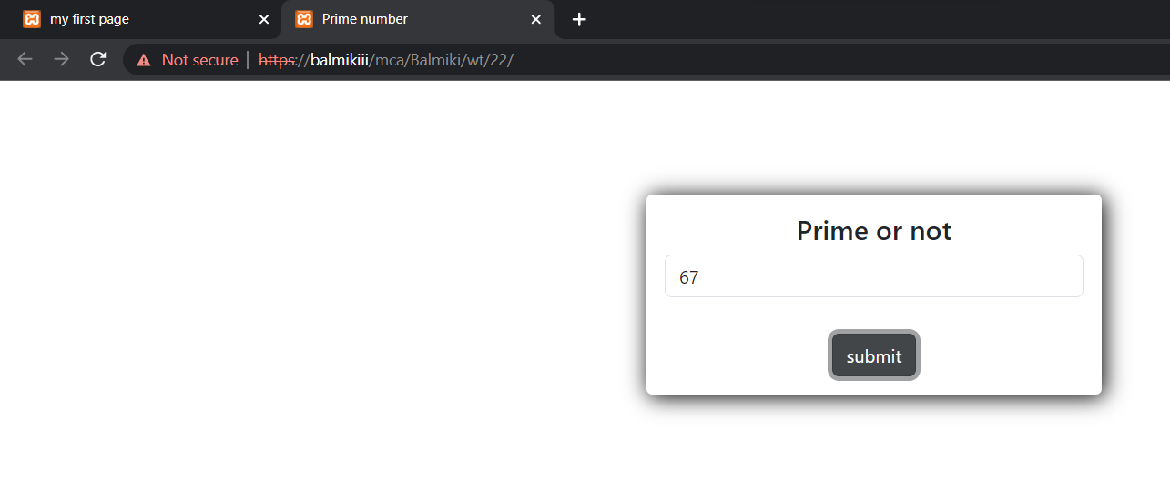

            else

                alert(n + " is not prime");

        }

    </script>

</body>

</html>

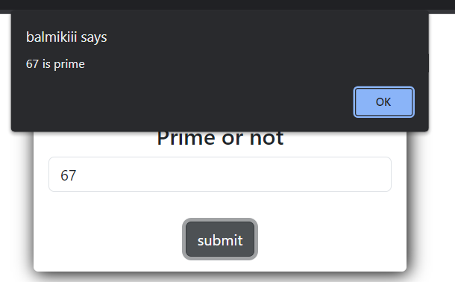

**23. Write a program to show multiplication table of any number.**

<!DOCTYPE html>

<head>

    <title>Input operation</title>

    <link href="../3rd/css/bootstrap.min.css" rel="stylesheet">

    <script src="../3rd/js/bootstrap.bundle.min.js"></script>

    <link href="//maxcdn.bootstrapcdn.com/font-awesome/4.7.0/css/font-awesome.min.css" rel="stylesheet">

<style>

    .regit{

        width: 400px;

        margin-left: auto;

        margin-right: auto;

        border-radius: 5px;

        margin-top: 100px;

        box-shadow: 2px 2px 19px black;

    }

</style>

</head>

<body>

    <div class="regit pt-3 pb-3 pe-3 ps-3">

        <div class="text-center h4">Table of any number</div>

        <input type="number" id="number" class="form-control mb-3" placeholder="Enter any number">

        <p id="resPara" style="display:none">It is an <span id="res"></span> Number</p>

        <div id="result"></div>

        <div class="text-center pt-3">

            <button onclick="fun()" class="btn btn-dark">submit</button>

        </div>

    </div>

        <script>

            function fun() {

            var table;

            table='<table class="table table-hover" id="mtable">';

            var num=document.getElementById("number").value;

            if(num==null || num=="")

            num=5;

               for(i=1;i<=10;i++){

                  table+='<tr><td>'+num+ ' X ' +i+ ' = ' +num*i+'</td></tr>';

               }

            table+='</table>';

            document.getElementById("result").innerHTML = table;

            }

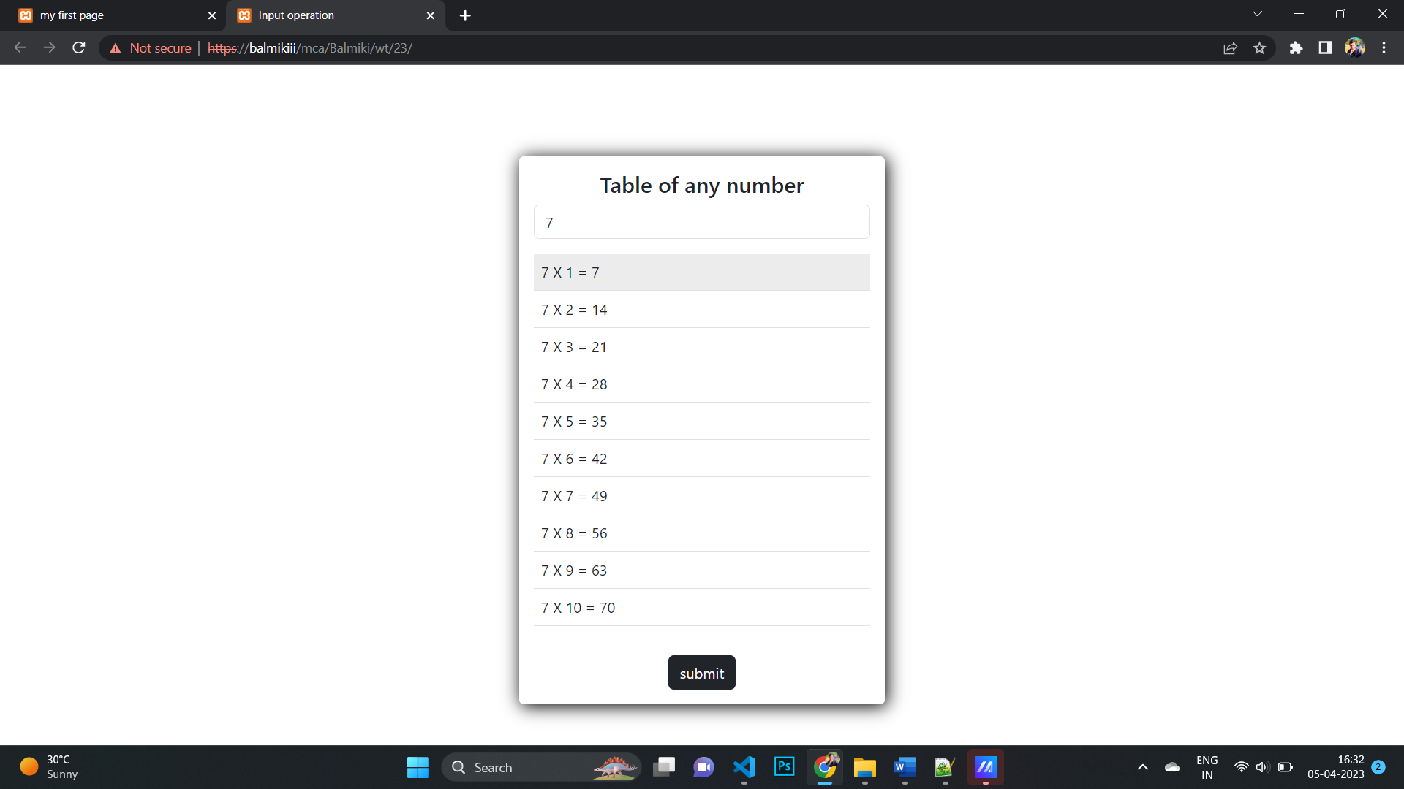

        </script>

</body>

</html>

**24. Write a program to find the factorial of any number.**

<!DOCTYPE html>

<head>

    <title>factorial number</title>

    <link href="../3rd/css/bootstrap.min.css" rel="stylesheet">

    <script src="../3rd/js/bootstrap.bundle.min.js"></script>

    <link href="//maxcdn.bootstrapcdn.com/font-awesome/4.7.0/css/font-awesome.min.css" rel="stylesheet">

<style>

    .regit{

        width: 400px;

        margin-left: auto;

        margin-right: auto;

        border-radius: 5px;

        margin-top: 100px;

        box-shadow: 2px 2px 19px black;

    }

</style>

</head>

<body>

    <div class="regit pt-3 pb-3 pe-3 ps-3">

        <div class="text-center h4">factorial number</div>

            <input type="number" id="n" class="form-control mb-3" placeholder="Enter factorial number">

            <p id="b"></p>

            <div class="text-center pt-3">

                <button onclick="fact1()" class="btn btn-dark">Check</button>

            </div>

    </div>

    <script>

        function fact(num){

            if (num == 0) {

            return 1;

            }else {

            return num * fact( num - 1 );

            }}

            function fact1(){

            var num = document.getElementById("n").value;

            var f = fact(num);

            document.getElementById("b").innerHTML="The factorial of the number " + num + " is: " + f ;

            }

    </script>

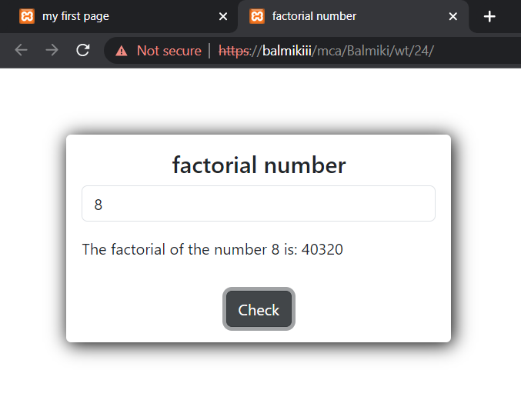

</body>

</html>

**25. Write a program to show Fibonacci Series between 0 to 74.**

<!DOCTYPE html>

<head>

    <title>Fibonacci</title>

    <link href="../3rd/css/bootstrap.min.css" rel="stylesheet">

    <script src="../3rd/js/bootstrap.bundle.min.js"></script>

    <link href="//maxcdn.bootstrapcdn.com/font-awesome/4.7.0/css/font-awesome.min.css" rel="stylesheet">

<style>

    .regit{

        width: 400px;

        margin-left: auto;

        margin-right: auto;

        border-radius: 5px;

        margin-top: 100px;

        box-shadow: 2px 2px 19px black;

    }

</style>

</head>

<body>

    <div class="regit pt-3 pb-3 pe-3 ps-3">

        <div class="text-center h4">Fibonacci number</div>

        <input type="number" id="n" class="form-control mb-3" placeholder="sum of Fibonacci Series">

        <p id="b"></p>

        <div class="text-center pt-3">

            <button onclick="fact1()" class="btn btn-dark">Check</button>

        </div>

    </div>

    <script>

        function fibo( num){

        var n1 = 0;

        var n2 = 1;

        var temp;

        var i = 0;

        for (i = 0; i < num; i++){

            temp = n1 + n2;

            n1 = n2;

            n2 = temp;

        } return n2;

        }

        function fact1(){

        var num = document.getElementById("n").value;

        var f = fibo(num);

        document.getElementById("b").innerHTML= "The sum of Fibonacci Series is: " +fibo(f);

        }

    </script>

</body>

</html>

